Release Notes

Version 8.1
Build 3.0

This document contains information that is confidential and proprietary to Volicon Corporation and may not be reproduced in any form without express written consent of Broadcom. No transfer or licensing of technology is implied by this document.

Table of Contents
1. Introduction 4
1.1 Purpose 4
1.2 References 4
1.3 Definitions and Acronyms 4
2. General 4
2.1 Hardware consideration 4
2.2 No Version Interoperability 4
3. Compatible Products and Platforms 4
3.1 Operating systems 4
3.1.1 Central Server Installations 4
3.1.2 Probe Installations 4
3.1.3 PC Clients 4
3.2 Capture cards 4
3.2.1 Transport Stream Capture cards 4
3.2.2 Other Capture cards 4
3.3 Browsers 5
3.3.1 HTML5 5
3.3.2 Internet Explorer 5
4. New features in 8.1.2 5
4.1 Light-Editor 5
4.2 ClearCable Publisher 5
5. New features in 8.1.3 5
5.1 Add link to local file as destination for Share 5
5.2 Add ability to upload to Facebook as “Un-Published” 6
5.1 Customer defined legal / IT warning on every login 6
5.2 Ports requirements: 7
6. 8.1 New Features 8
6.1 STB & Manual Mode 8
6.1.1 Enabling Manual Mode 8
6.1.2 Exiting Manual Mode 9
6.1.3 Using Manual mode 9
6.1.4 Rules for Manual Mode 11
6.1.5 Definition of Key Terms 12
6.1.6 Configuring STB Information 12
6.1.7 Scripts 12
Defining Scripts 12
Editing Scripts 13
Deleting Scripts 13
Filtering Scripts 14
6.1.8 Services 14
Defining Services 14
Editing Services 15
Deleting Services 15
Filtering Services 16
6.1.9 Bouquets 16
Adding a New Bouquet 16
Importing a Bouquet 17
Editing Bouquets 18
Deleting Bouquets 20
Filtering Bouquets 22
6.1.10 Manual Schedule Recording 22
Creating an event 22
Deleting event 24
Filtering events 25
6.1.11 Additional Capabilities 26
6.1.12 EPG (Electronic Program Guide) 26
Loading the EPG 26
6.1.13 Adding Programs to Schedule Recording 27
6.2 Ooyala native: Replace Existing File Name 28
6.3 Ooyala native: Adding Labels 28
7. New Features in 8.1.2 and 8.1.3 29
7.1 Light Editor: 29
7.1.1 Assigning SLE to users 29
7.1.2 Assigning Asset Library to users 29
7.1.3 Asset library 30
7.1.4 Share Light Editor Use 33
7.2 LocalShare 40
7.3 Multi Share 40
8. Bug Fixes 42
9. Known Bugs and Limitations 43
9.1 Light Editor open issues: 43
9.2 Continuous and Schedule Export open issues: 44
9.3 Share & Export 44
9.4 HTML5 open issues: 45

Introduction

Purpose
The purpose of this document is communicating the major new features and changes in this release. It also documents known problems.

References
The following path links to relevant user guides:
http://mip.volicon.com/

Definitions and Acronyms
The following defines acronyms or terms commonly used in this document.
Services | A/V programs along with associated metadata
ARL | As Run Log
STB | Set Top Box
TS | Transport Stream
MH | Media Hub- internal Observer component
CC | Closed Captions
OTT | Over the Top

General
This release includes the features:
- Default CC per share destination
- Multi share destination
- Manual CC adjust per share operation
- Ooyala native- replace existing
- Equipment alerts
- OTT Cloud configuration support
- STB support- Manual mode
- Schedule Recording
- EPG
- Slicer Integration
- LTW to AWS
- Hide Sub Encoders drop down
- Localization
- Slates detection
- No transcoding for OTT streams
- Support creating XDS based programs from encrypted TS
- Share Light-Editor
- ClearCable Publisher
- Customer defined legal / IT warning on every login
- Add link to local file as destination for Share
- Add ability to upload to Facebook as “Un-Published”

Hardware consideration
- 8.1 supports only 64-bit systems (Central Server and Probe)
- The CEM and Thumbnails services can be installed directly on the CS if server has at least 8 GB RAM and less than 50% CPU utilization.
- In case of a standalone server (CS + Probe on the same machine), it is necessary to install the CEM and Thumbnails services on a separate server. The Thumbnails feature requires a large amount of storage- For one encoder, one day takes approximately ~400MB

No Version Interoperability
There is NO Version Interoperability with the 8.1 QB1 software.
- The Central Server and Probe must both be on 8.1 QB1 in order to communicate.
- In addition, the player must match the 8.1 QB1 software version in order to view content from a Client Machine.

Compatible Products and Platforms
This product was tested on the following platforms (or with the following products):

Operating systems

Central Server Installations
- Windows 2012 R2 x64
- Windows 10 x64
- AWS Win 2012 R2 servers
- Windows 7 x64

Probe Installations
- Windows 2012 R2
- Windows 10
- AWS Win 2012 R2 servers
- Windows 7 x64

PC Clients
- Windows 7 64-bit
- Windows 10 64-bit

Capture cards

Transport Stream Capture cards
- Hauppauge (Added support for 1069 card)
- Dektec
  - Latest driver in use: (Same as 7.2 QB2)
  - DekTec DTA-xxxx Driver Version 4.10.0.144 (Driver Date 10/29/2014)
  - Hauppauge : Hauppauge WinTV-HVR-2255 (old 2250) Driver Version 7.9.1.32199 (Driver Date 07/18/2014)
  - Supported: DTA 2111, DTA 2135, DTA 2136, DTA 2137, DTA 2145, DTA 2160

Other Capture cards
- Blackmagic
- Ospray

Browsers

HTML5
The following HTML5 browsers are supported:
- Edge
- Safari
- Chrome
- Firefox

Internet Explorer
The following 64-bit versions of Internet Explorer are supported:
- IE11 (supported using Active X player)

If you are using a non 64-bit version of Internet Explorer, please run the below executable for IE 64:

New features in 8.1.2

Light-Editor
Share light editor (SLE) enables users to edit video before publishing. New Features Include:
  - Adding Intro/Outro to the clip from pre-defined list of videos
  - Adding Slate to the clip.
  - Splicing clips

ClearCable Publisher
New publisher called ClearCable is now supported (mrss is natively configured for customer who purchase this profile)

New features in 8.1.3

Add link to local file as destination for Share
When users choose to share to this destination, the clip is processed by the CEM and then written to the default local path on the CEM with a link to download this file being provided to the user.

Add ability to upload to Facebook as “Un-Published”
This feature gives users the ability to upload a video and then edit the post on the FB interface where they can add tagging and other features that are not available in the API.

Customer defined legal / IT warning on every login
A Customer-defined legal warning before every Volicon client login can be enabled

Ports requirements:
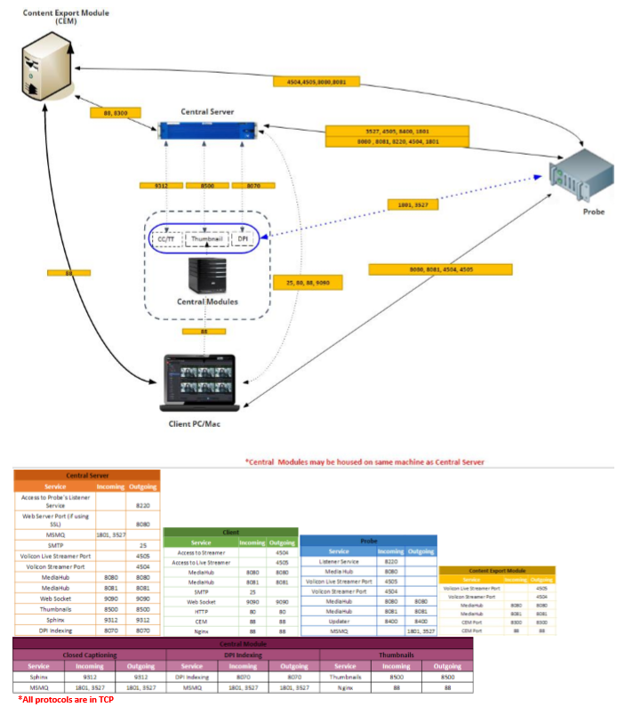

8.1 New Features

STB & Manual Mode
Manual mode allows users to manually access any channel or service on the Encoder (whose Input type is Set Top Box). It also enables users to do media recording (scheduled recording) by issuing channel change commands to STBs and recording the content.

Enabling Manual Mode
- Encoder input type must be for STB
- On Volicon Setup page, Product Type needs to be set to STB instead of STD
- To enter Manual mode, go to Viewer page and click on “Remote control available” button

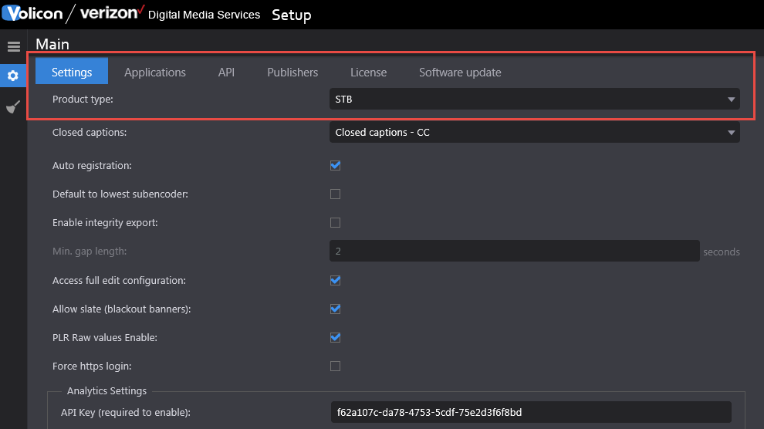

Exiting Manual Mode
- Close the player by unchecking the channel from the channel dashboard.
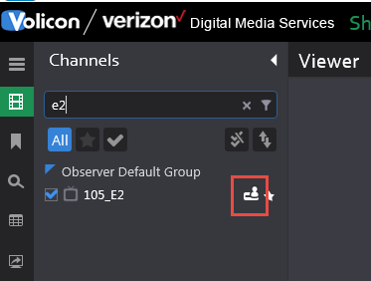
- Explicitly click on the STB Icon in front of channel name.

Using Manual mode
- When user enters manual mode, a message is displayed that an “open” command has been issued.

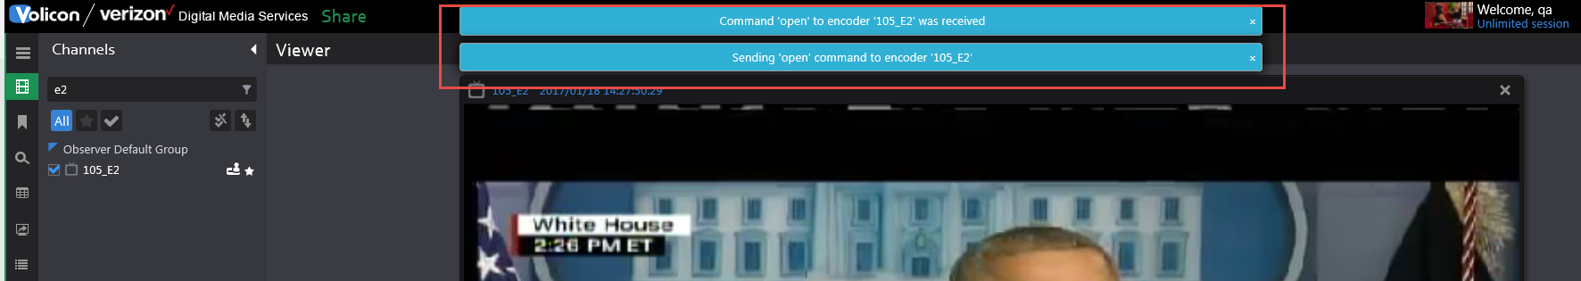

- The icon (highlighted in red) changes to indicate the user who is now controlling the STB.

- Player connects to LIVE port and starts playing Live. All player controls such as mark-in, mark-out, forward, rewind, calendar etc. are disabled except for volume buttons and change hour span.
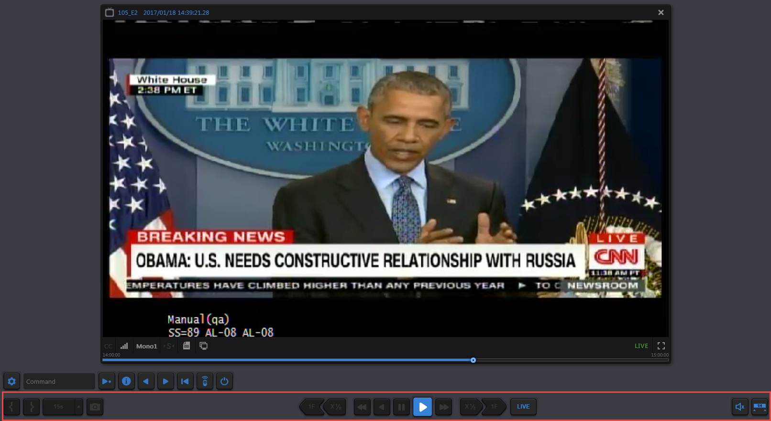

- In addition, a remote control bar opens to control STB.

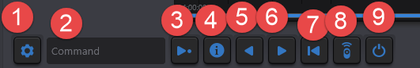

1 – Services – Connect directly using Service name
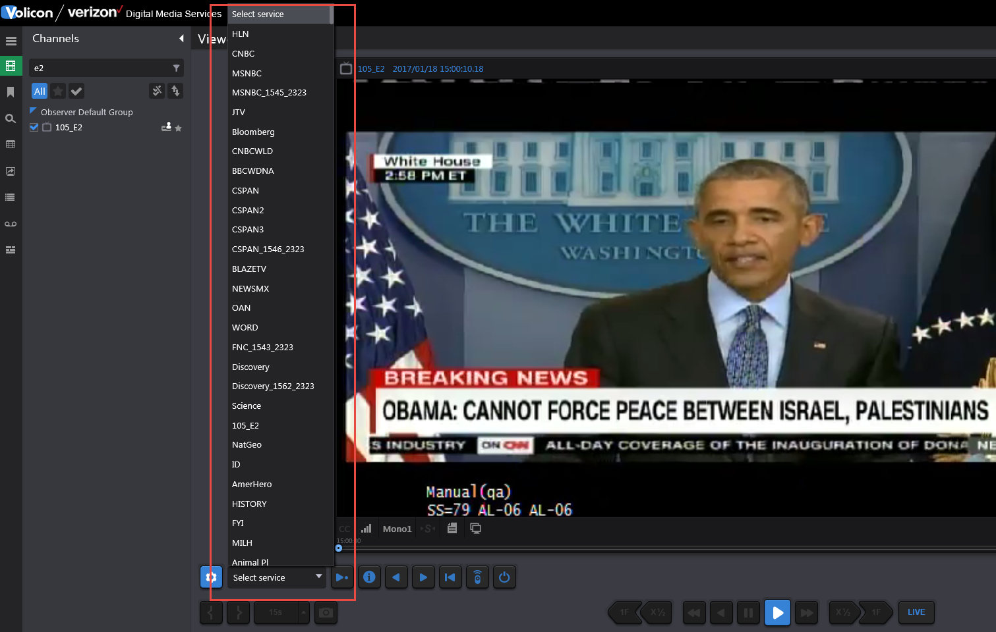

2 – Command – Text box where user can enter different commands to be issued to STB such as Channel number or guide (similar to commands on remote)
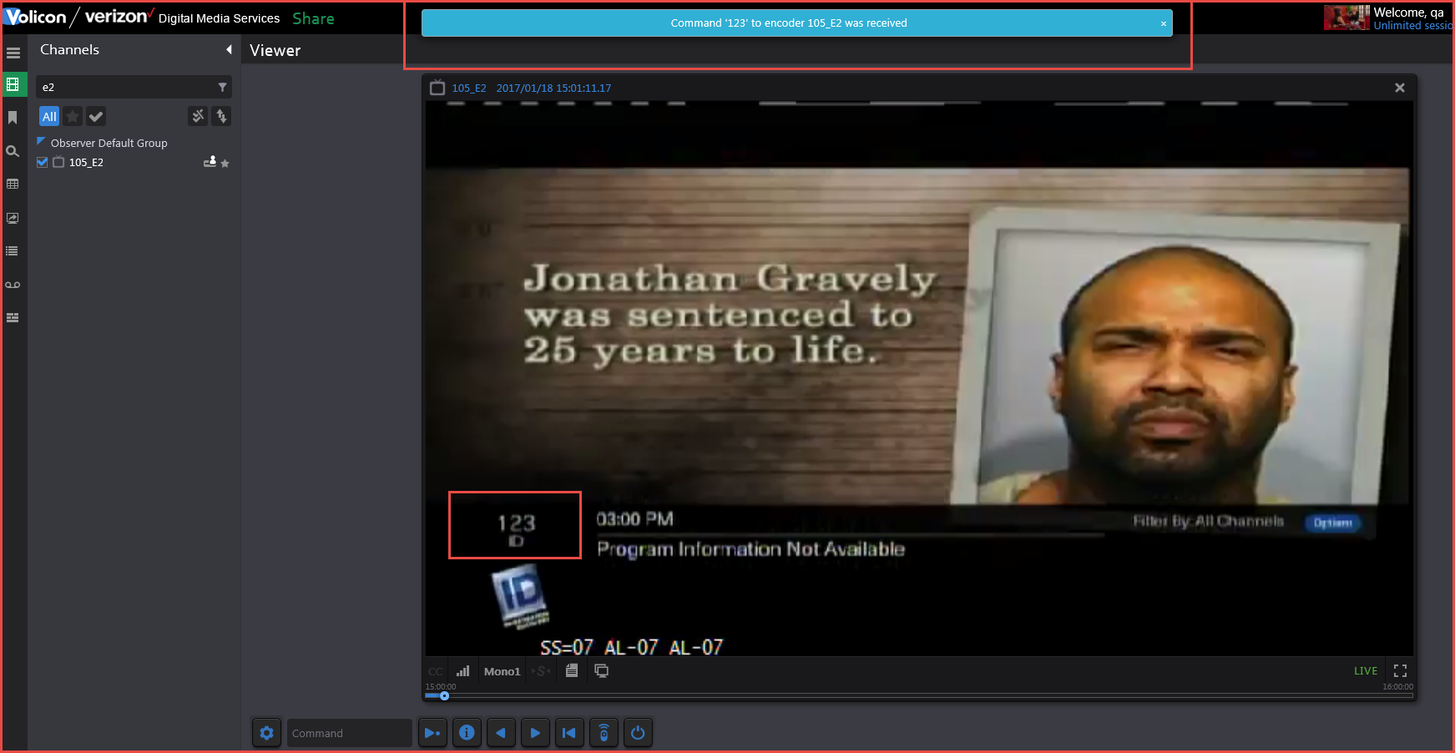

3 – Enter – Execute the command mentioned in Text box
4 – Info – Command STB to display information about the program currently running
5 – Previous Channel – Connect to previous channel
6 – Next channel – Connect to next channel
7 – Last Channel – Returns STB to last channel tuned to. For example, if tuned to channel 100 and then tuned to channel 123, clicking “Last” would return STB to channel 100.
8– Remote Control- Brings up a graphic remote control (if programmed for the type of STB used)
9– Power On/Off - Command brings STB in/out of standby mode

Rules for Manual Mode
- Different states of Remote Control-
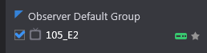 – Remote Control Available
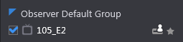 –User is controlling the STB and hence remote
control is not available (hover above icon to display name of user accessing STB)
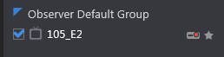 - Scheduler is controlling it, which means Schedule recording is on (hence user will not be able to access manual mode for that encoder)

Definition of Key Terms
TERM | DEFINITION
Encoder/Stream | Encoder receives and processes media signals from STB.
Service/Channel | Network’s media service content as perceived by the end user. Typically a cable , broadcast channel or specialty service
Bouquet | A mapping of channel numbers to virtual channel numbers to allow for use by STB in creating things such as scheduled record or manual mode channel changing

Configuring STB Information
The following steps need to be followed in order for STB and Schedule recording to work properly:
- Define Scripts – Used by Schedule recording module to define what should happen before and after the recording of a particular service/channel finishes.
- Define Services – Contains all the content provider’s services that need to be available for the encoders/probes throughout the system.
- Define Bouquets – Associate services with their dial numbers (channel numbers) for specific providers and geographical locations. Multiple bouquets are defined according to the STB Type, location, provider etc.
- Define STB – Associate remote image with IR file (created by IR Trainer) and the corresponding PHP file.

Scripts
Scripts are used to execute commands on Services, like during a Schedule recording.

Defining Scripts
- Go to Settings -> STB -> Scripts tab
- Click on + button to add a new script.
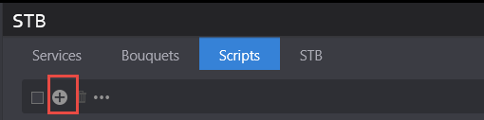

- Complete the following script parameters:

Name – A meaningful name describing the script and its intent
Description – Script description
Script – Command to execute
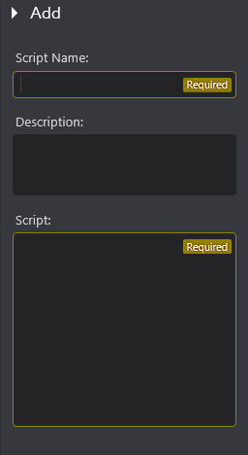

Editing Scripts
- Go to Settings -> STB -> Scripts tab
- Hover mouse on the record to be edited and click on Edit button
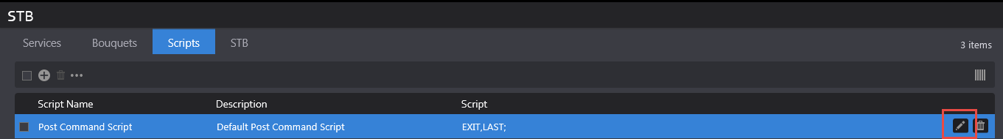
- Save changes or Cancel them

Deleting Scripts
- Go to Settings -> STB -> Scripts tab
- Hover mouse on the record to be deleted and click on Delete button
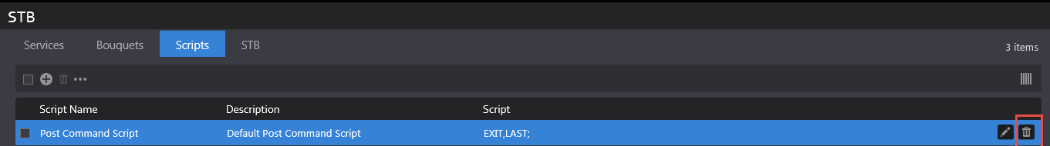
- Dialog box will appear for user’s confirmation
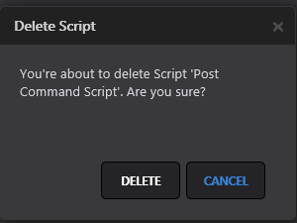
- Click on Delete button on dialog box to delete the script or cancel button to cancel deletion
- Records can also be deleted by selecting several records and clicking the Delete All button

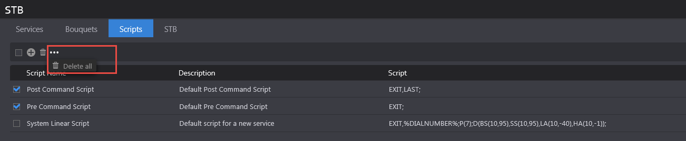
- Dialog box will appear for user’s confirmation
- Click Delete button on dialog box to delete the scripts or cancel button to cancel deletions

Filtering Scripts
- Go to Settings -> STB -> Scripts tab
- At Search panel on the left side of the page, enter text that you want to search
- Search will be performed on the Script Name field
- Click on Reset button to clear the search results and restore all records on the page.

Services
A pool of services is defined on the CS to access channel programs through scripts, manual mode and schedules.
The broadcast types on different channels are:
- Linear
- On-demand
- Interactive TV Services such as Arts & Entertainment, VOD Play Out, IMG Check , etc.

Defining Services
- Go to Settings -> STB -> Services tab
- Click on + button to add a new Service.
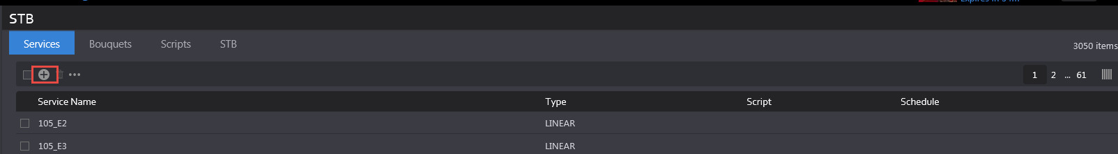

- Enter a meaningful name for the service and click save
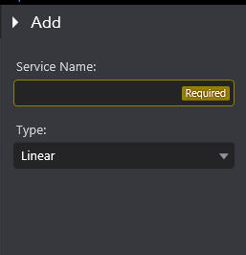

Editing Services
- Go to Settings -> STB -> Services tab
- Hover mouse on the record to be edited and click on Edit button
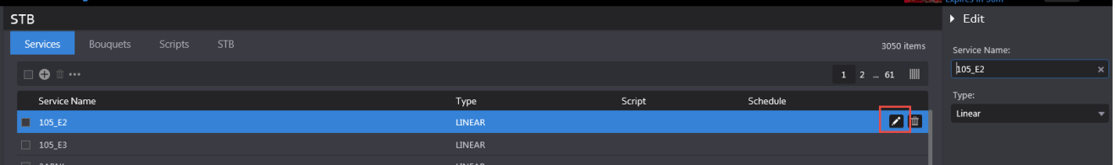
- Save changes or cancel them

Deleting Services
- Go to Settings -> STB -> Services tab
- Hover mouse on the record to be deleted and click on Delete button
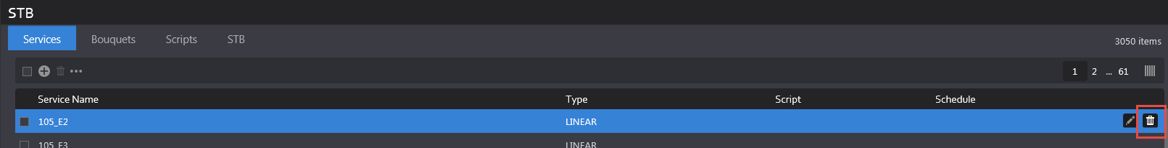
- Dialog box will appear for user’s confirmation
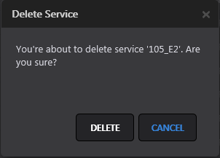
- Click Delete button on dialog box to delete the service or cancel button to cancel deletion
- Records can also be deleted by selecting several records and clicking the Delete All button
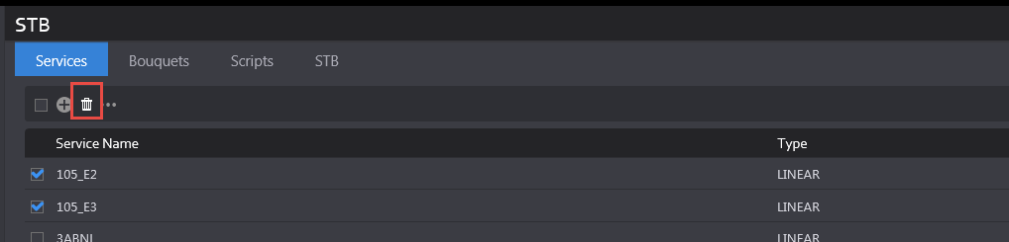
- To delete all services from all pages, use Delete All option as shown below:
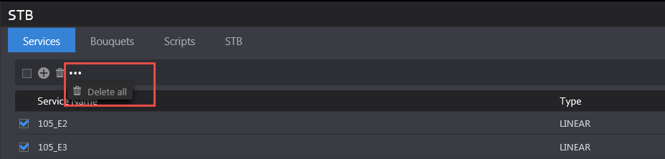

- Dialog box will appear for user’s confirmation
- Click on Delete button on dialog box to delete the scripts or cancel button to cancel deletion

Filtering Services
- Go to Settings -> STB -> Services tab
- At Search panel on the left side of the page, enter text that you want to search
- Search will be performed on the Service Name field
- Click on Reset button to clear the search results and restore all records on the page.

Bouquets
- A bouquet may be used with one or more encoders
- Different bouquets may have different associations
  - A&E, 327 (in NYC)
  - A&E, 528 (in NJ)

Adding a New Bouquet
- Go to Settings -> STB -> Bouquets tab
- Click on + button to add a new bouquet.
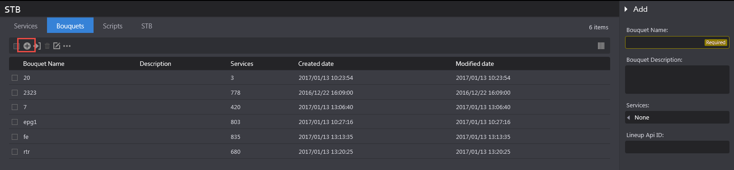

- Enter a meaningful name for the bouquet and a description
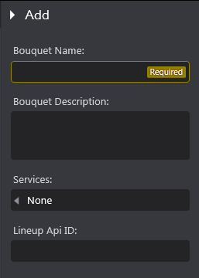

- Click on Services textbox to add services to the bouquet. This field will be disabled if no services exist on Services tab. If there are existing services, user can search the service name, enter a dial number in the textbox next to Service name and click on Ok Button.
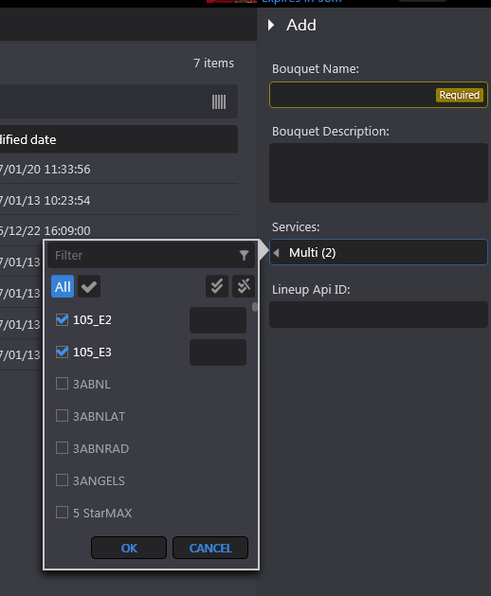
- If a user creates a new bouquet with an already existing name, an error message is displayed to the user that the same name cannot be used.

Importing a Bouquet
A bouquet can be imported from a CSV File. The format of the file is as follows (first column is Service name and second column is Dial number):
5 StarMAX | 338
A&E Network | 37
A&E Network HD East | 837
ActionMAX | 343

- Go to Settings -> STB -> Bouquets tab
- Hover mouse over an existing bouquet entry.

- Click on Import Services button
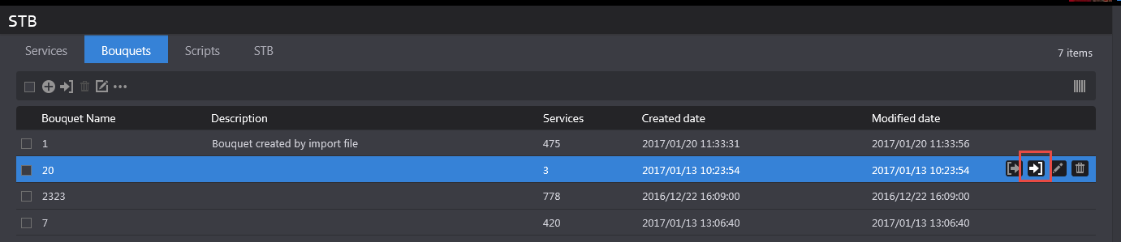
- On the dialog box, click on Select File button to select a CSV file from your folder structure.
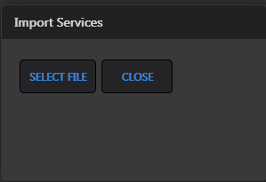
- User gets a confirmation message that “Services are imported successfully”
- Notice that the description is set to “Bouquet created by import file” by default and the services number column is updated based on the number of services mentioned in the CSV file.

Rules for Importing Bouquet
- Services not existing in a bouquet will be added to it
- Services missing in the imported file but defined in the Bouquet will be left in the Bouquet.

Editing Bouquets
Bouquet can be edited one at a time however, some functions can be performed on all bouquets simultaneously such as Add Service, Change service dial number or Delete service.
Add Service
- Click on “Add service” option from the menu.
- On the “Add Service” dialog box, click on the Service name arrow and select the service that needs to be added to all bouquets.
- Mention the Dial number and click on Save.
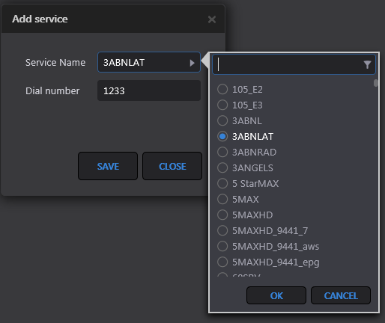

- A confirmation message appears to the user when operation finishes.

Change service dial number
This function allows users to change dial number for a service in all the bouquets.
- Click on “Change service dial number” option from the menu and on the dialog box.
- Click on the Service name arrow and select the service for which dial number needs to be changed.
- Mention the new dial number in Dial number field.
- Click on Save.
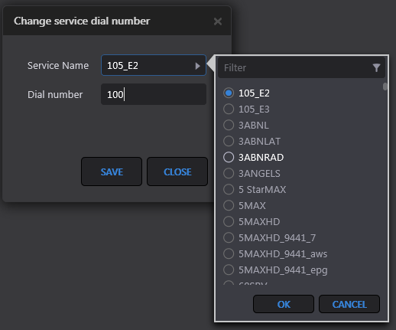
- A confirmation message appears to the user when operation finishes.

Delete Service
This function allows users to delete a service from all the bouquets
- Click on “Delete service” option from the menu and on the dialog box
- Click on the Service name arrow and select the service that needs to be deleted.
- Click on Delete button.
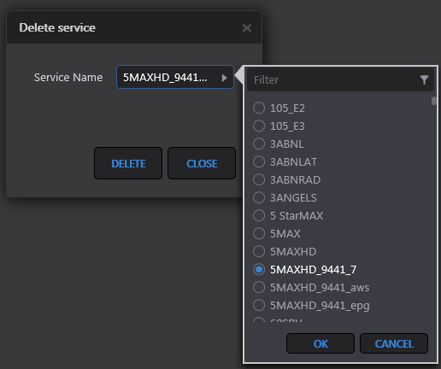
- A confirmation message appears to the user when operation finishes.

Deleting Bouquets
A Bouquet can be deleted one at a time or multiple bouquets can be deleted at once.
Delete a single bouquet
- Hover mouse over a record and click on the Delete button.
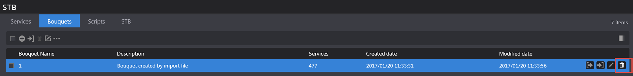
- Click on “Delete” button on the dialog box.
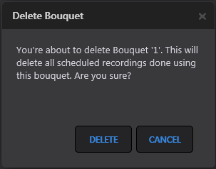

Deleting multiple bouquets

- To delete multiple bouquets at the same time, select the bouquets and then click on the “Delete All” button on the menu.
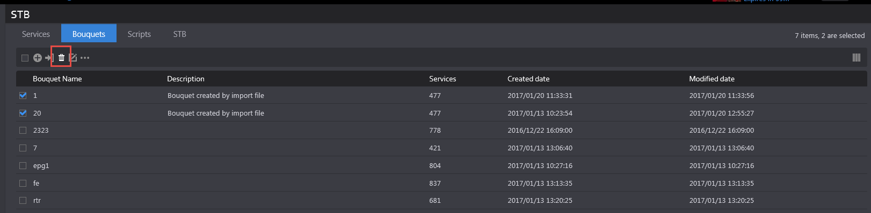

- Click “Delete” button on the dialog box
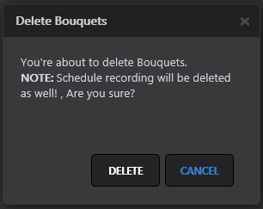

- Users can also use “Delete All” option from the menu to delete all bouquets from all the pages.
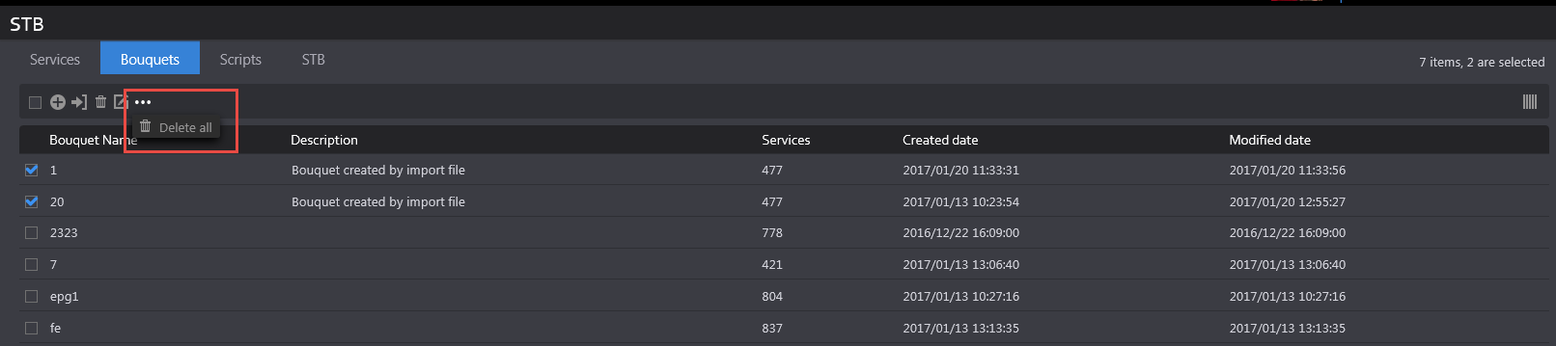

- Click the “Delete” button on dialog box for confirmation.

Filtering Bouquets
- Go to Settings -> STB -> Bouquet tab
- On Search panel at the left side of the page, enter text that you want to search
- Search will be performed on the Bouquet Name field
- Click on Reset button to clear the search results and restore all records on the page.

Manual Schedule Recording
This module allows users to record a channel/service during specified periods. The events or jobs created can be a onetime recording or reoccurring recordings.

Creating an event
- Go to a module such as Share, Comply or Monitor and click on the “Scheduled recording” page.
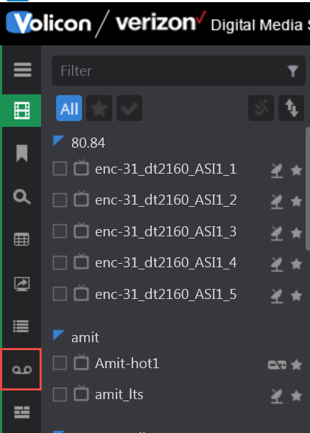

- Click on + (Add event) button from the top menu
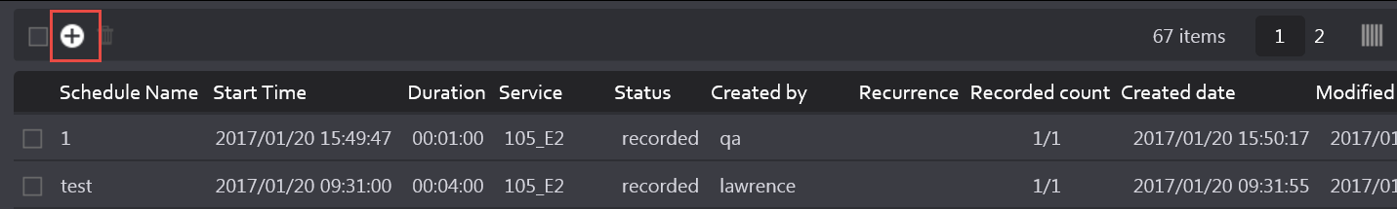

- On “Add” screen, select the parameters:
    - Event Name – Name of the recorded event
    - Bouquet – Select the bouquet, which contains your service/channel
    - Service – Select service/channel from the loaded list
    - From and To – Select Start and End date/time for the program/recording
    - Encoder – Select the stream, which will be displayed automatically after user selects the service/bouquet (The mapping of encoder with bouquet is done by the administrator in the Configuration page)

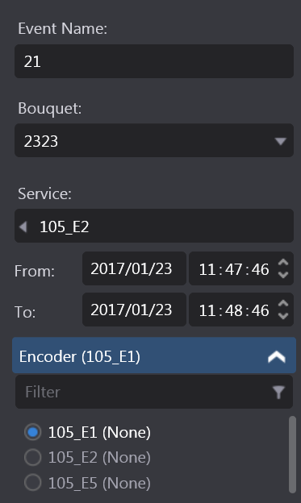

- For recording options please see below:
  - To record only once, do not select the checkbox
  - To record a channel/service on multiple days, select the Repeat checkbox
- If value in textbox = 1, then recording will happen daily
- If value = 2, recording will happen every 2nd day, and so on until end condition is specified for the recording
- If “until” checkbox is not selected, recording will happen for an unlimited number of days.
- If “until” checkbox is selected, user can specify the date/time until which job needs to record the channel.

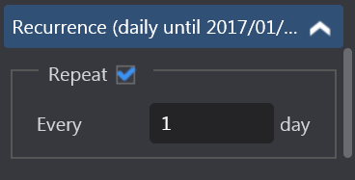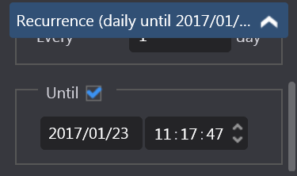
- Click on the Save button and observe that the job will be in “Scheduled” state.
*NOTE*
When user creates a Scheduled record event and it is the same time for which another event has already been scheduled, then the encoder will appear disabled and user will be unable to select the radio- button for that encoder.
The Service name will appear in the parenthesis following Encoder name indicating which channel is being recorded during that time.

Deleting event
- Go to an application like Share, Comply, Monitor and click on “Scheduled recording” page.
- Hover mouse on the record to be deleted and click on Delete button.
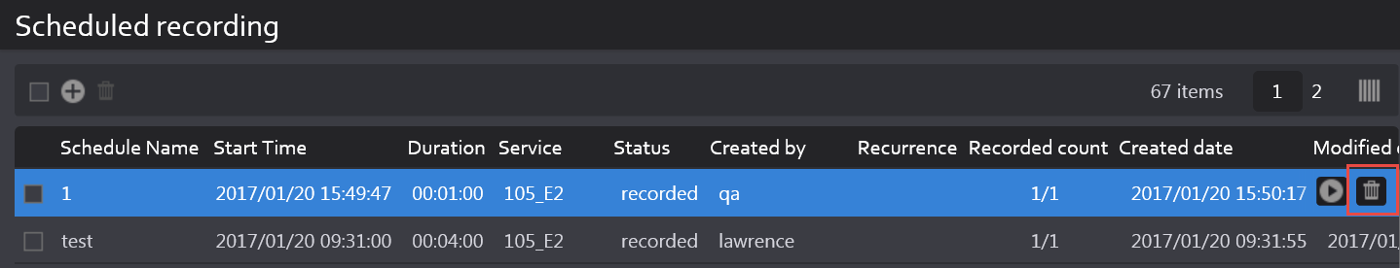
- Dialog box will appear for user’s confirmation.
- Click on Delete button on dialog box to delete the service or cancel button to cancel deletion.
- Records can also be deleted by selecting several records and clicking on Delete All button.
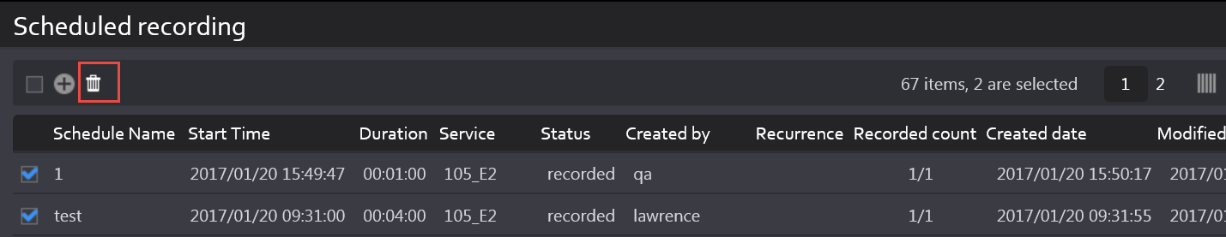

- Dialog box will appear for user’s confirmation.
- Click on Delete button on dialog box to delete the scheduled recording events or cancel button to cancel deletion.

Filtering events
- Go to an application like Share, Comply, or Monitor and click on “Scheduled recording” page.
- Scheduled recording events can be filtered on many parameters. They are as follows:
    - Keyword – Returns records which contain searched text in “Schedule Name” field
    - Bouquet – Select a bouquet in which search needs to be performed
    - Service – List of services associated with selected bouquet will be loaded. User can select up to 10 services while performing search

- Status – A scheduled recording event has different statuses as follows:
  - Scheduled – When recording Start Time has not yet reached
  - Recording – When recording Start Time has reached and event is being recorded
  - Recorded – When event has been fully recorded
  - Failed – When event failed to record due various reasons
- Time Range – Enables user to perform search on the recorded events based on their “Created Date”
  - Only those records will be returned which are created between the “From” and “To” date/time in the search criteria.
- Created By – Select up to 10 users in search criteria
- Encoders – Search by selected encoders
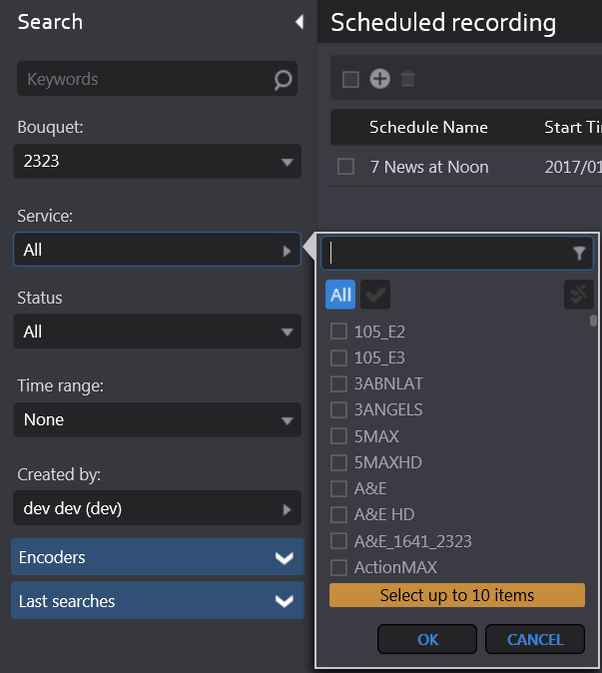
- Click on Search button. Search is performed based on the criteria selected in #2
- Click on Reset button to clear the search results and restore all records on the page.

Additional Capabilities
- When the event status changes to “recorded”, the play button appears on the record. When user clicks on this button, player appears and user can view the clip. Along with viewing, user gets other clip capabilities like Export, Share, Edit, and Save Clip as Bookmark.
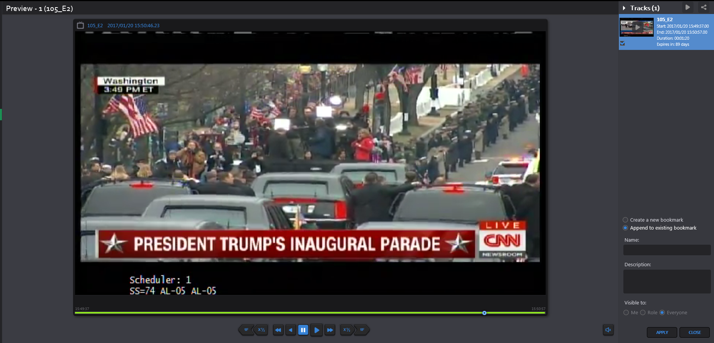
- Edit button appears on the record when event is in Scheduled state or Failed state. User can change different parameters like Start/End Date/Time, name of the event etc. but if an event completes successfully, he is not provided with editing capabilities.

EPG (Electronic Program Guide)
An electronic program guide (EPG) is used with digital set-top boxes to list current and scheduled programs that are or will be available on each channel and a short summary or commentary for each program.
- EPG is the electronic equivalent of a printed television program guide.
- EPG Scheduled Recording is a feature of the Observer STB that creates a “TV Guide” experience where the expected future broadcast schedule is displayed. Users can then select which program from this broadcast schedule should be recorded.

Loading the EPG
- Go to an application such as Share, Comply, or Monitor and click on EPG icon.
- User needs to fill up the Search form to load the page.
- Bouquet – Select the bouquet from drop down
- Keyword – Text matching program name
- Service – Select channel auto-populated according to the bouquet it is associated with. Maximum 10 items services can be selected in this field.
- Categories – Program categories
- Time Range – Define a time range - Start and End Time of program

- Click on Search button. A list of programs will be loaded on the page based on the search criteria
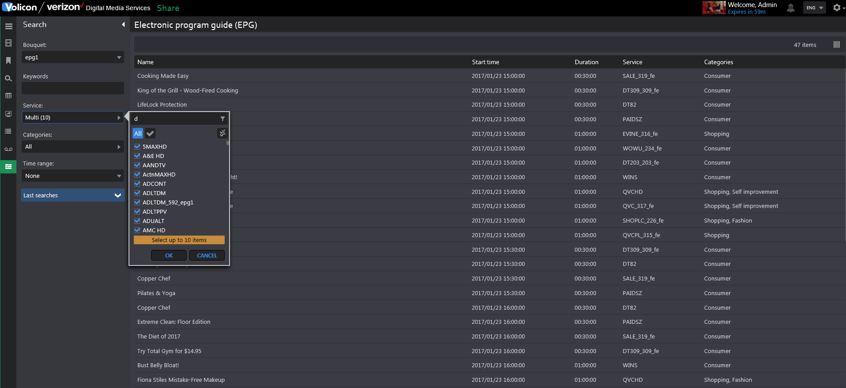

Adding Programs to Schedule Recording
- Go to an application like Share, Comply, or Monitor and click on EPG icon.
- Hover mouse over one of the records returned from Step 1 above.
- Click on + button and program info appears as a sliding window.
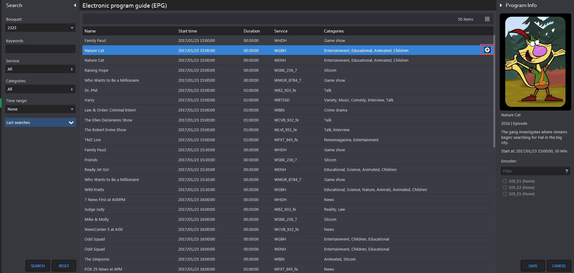
- Select the encoder (associated with the bouquet) for which recording needs to be done.
- Click Save. A confirmation message appears to the user and an event is created on Scheduled recording page (please reference images below)

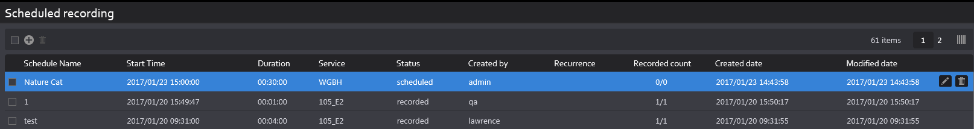

Ooyala native: Replace Existing File Name
Overview
With 8.1QB1 software, user will have option to “Override old file with same name” on Share page
- If you check off this box:
  - You will update or override an existing video file but keep original asset
- If you do not check off this box:
  - File will automatically be regenerated next day with updated file name (EX: “Evening news” video clip published on 1/1/17 will regenerate into a second file named “Evening news.1” on 1/2/17. “Evening news” will also still exist in system)

Ooyala native: Adding Labels
Overview
With 8.1QB1 software, user is able to add labels or tags from their Ooyala account directly to the content they are publishing
- On share page (before publishing clip), click right arrow on “Destination Parameters” window
- Select labels that are to be added to the clip and press “ok”

New Features in 8.1.2 and 8.1.3

Light Editor:
Introduction:
Share light editor (SLE) enables users to edit video before publishing. Examples of what can be done include adding an Intro/Outro to the clip from pre-defined list of videos and/or adding Slate to the clip.
There are two primary parts to Share light editor:
- Defining the videos/images, referred to as Assets, in the system to be used during editing clip
- Allowing users the Share light editor functionality by enabling it on Roles page.

Assigning SLE to users
- From the “Settings” page, select “Roles” from the list on the left-hand side of the screen
- Select the Role that you wish to add SLE to and from the page that appears, click the “Permissions” tab
- On the “Permissions” tab, check “Share light editor” as shown in the image below
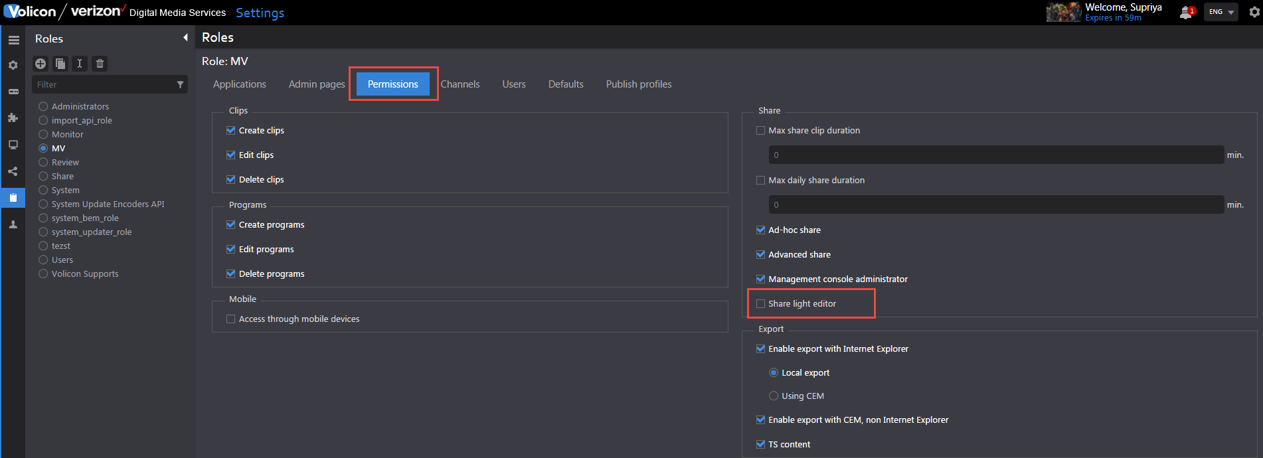

- This will enable SLE on the desired Role and all users, which are a part of this role, will have Share light Editor

Assigning Asset Library to users
- From the “Settings” page, select “Roles” from the list on the left-hand side of the screen
- Select the Role that you wish to add SLE to and from the page that appears, click the “Applications” tab
- On the “Applications” tab under the “Share” Module, check “Asset Libary” as shown in the image below
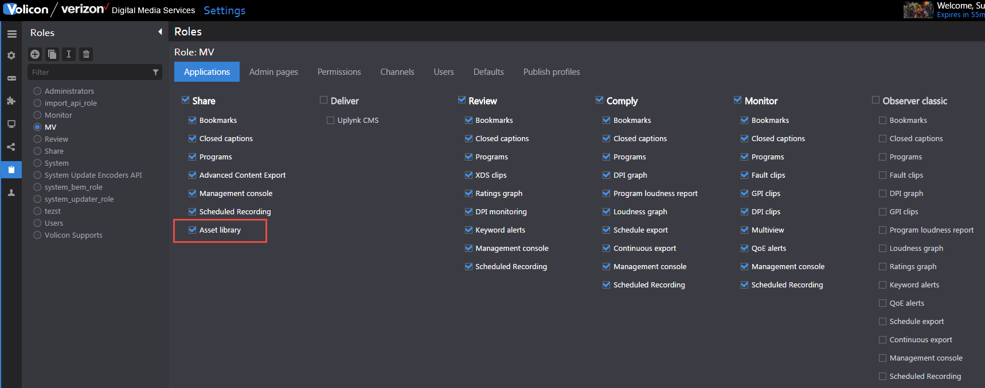

- This will enable Asset Library on the desired Role and all users, which are a part of this role, will be able to upload and manage a list of intros/outros.

Asset library
Overview:
This page is for managing the intro/outro (video) files and Slate (Image) files.

Adding Assets
- Asset can be added by clicking on + button and then from the sliding window that appears on the right-hand side of the screen selection the “Upload” button.
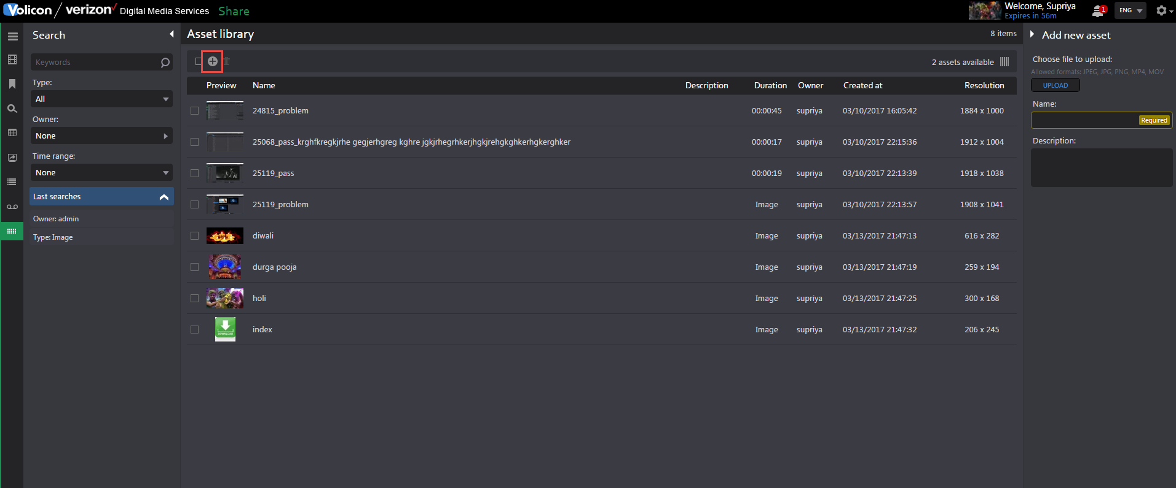

- From the popup that appears, select a file (video/image) from the folder structure. By default, name of the Asset is same as the uploaded file name.
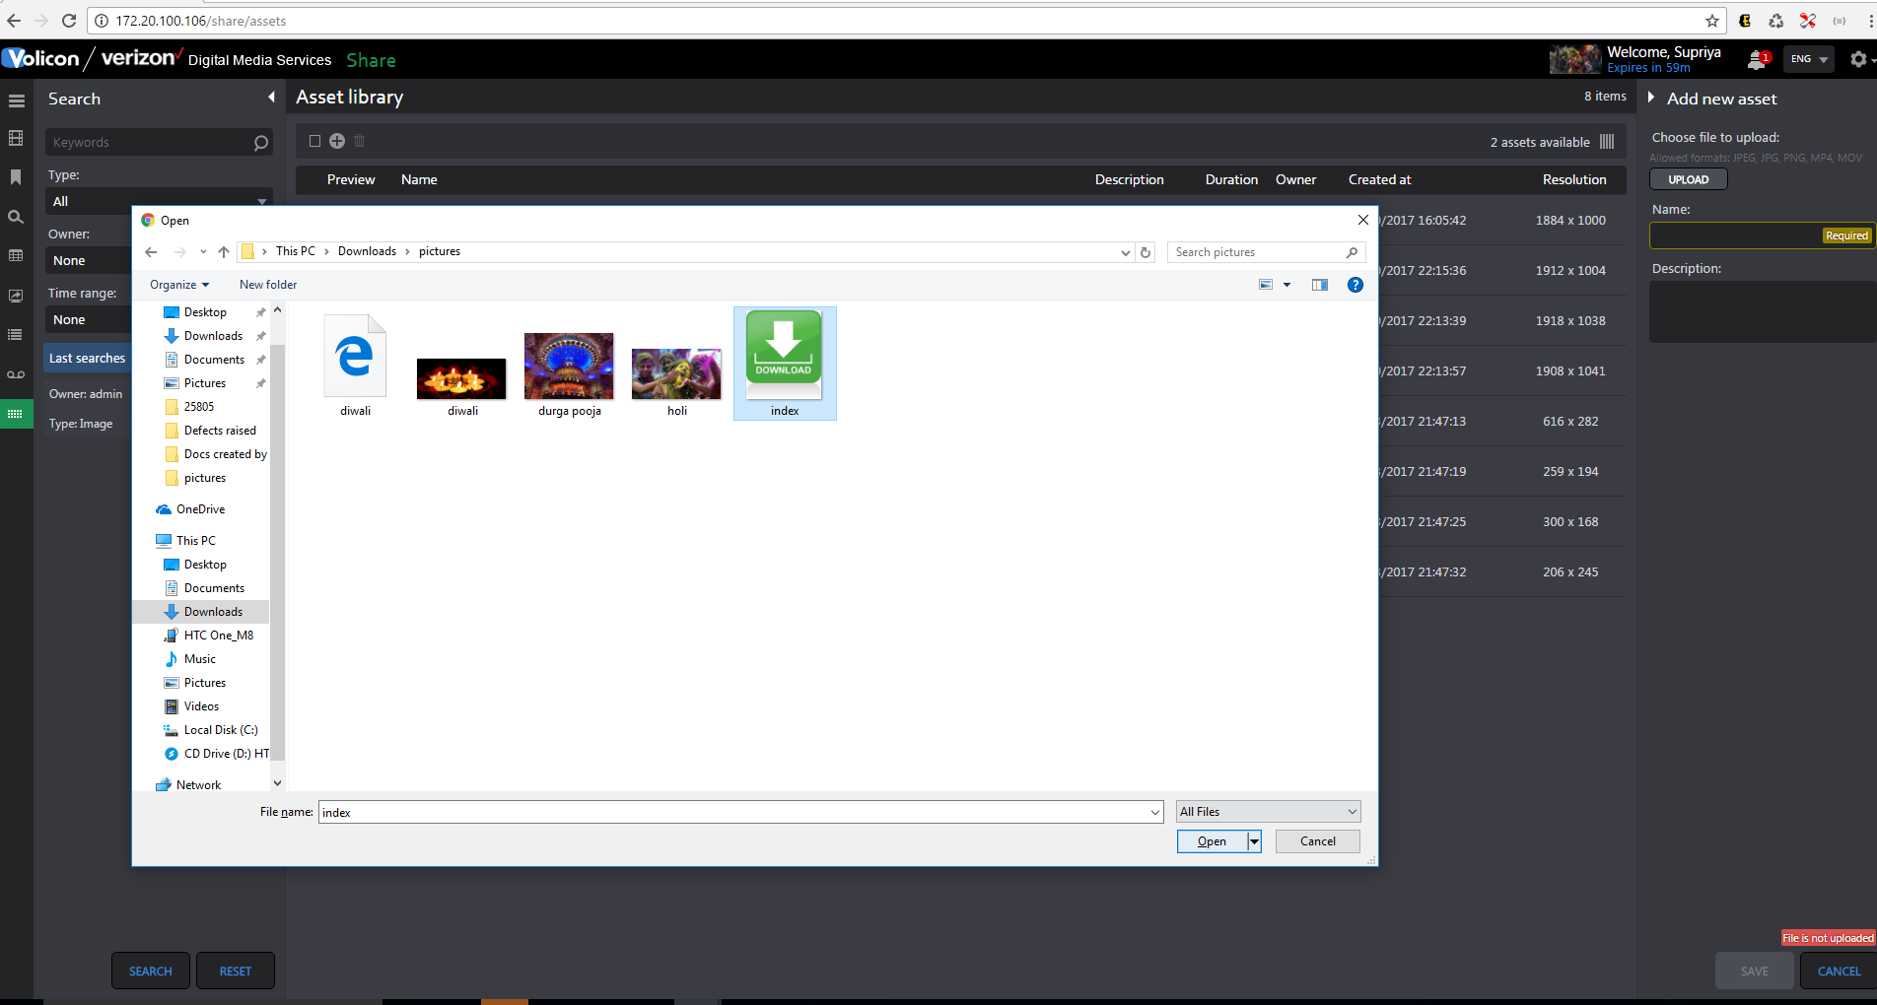
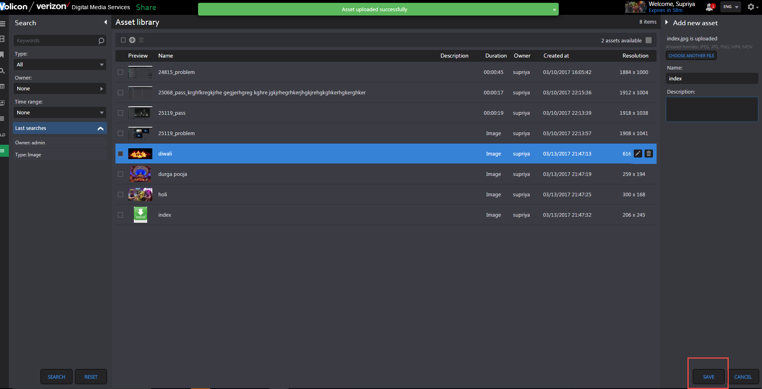
- Click on the “Save” button and a successful “Asset saved” message appears.
- Each asset will have properties such as name/description/duration/Owner/Created at and Resolution.

NOTE** Image Asset types will have “Image” mentioned in “Duration” column

Delete Assets
Users can delete Asset in two ways:
- By clicking on Delete button that appears on the asset when user hovers mouse.
- By selecting multiple Assets and clicking on “Delete All” button on the menu

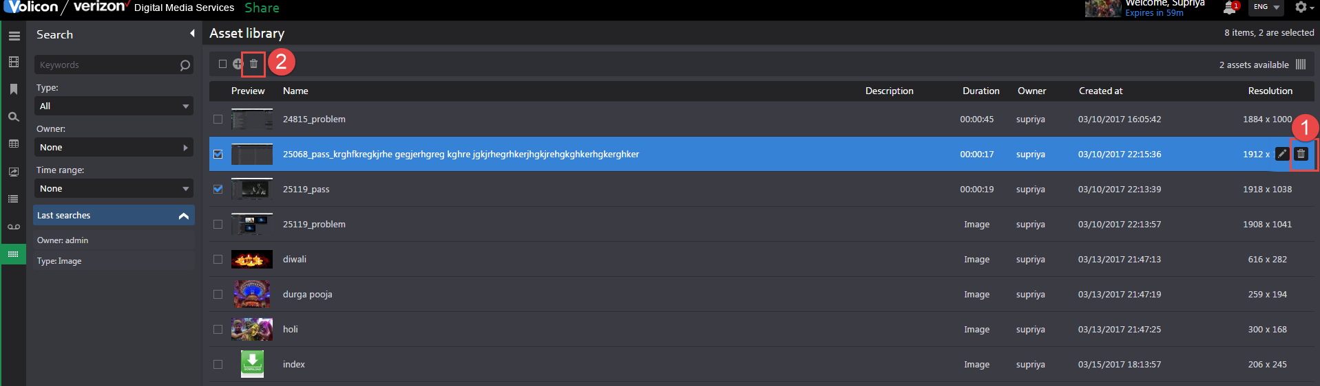

Preview Asset
- Users can preview the asset by clicking on Asset’s thumbnail as shown in the screenshots below.
NOTE** In case of Video asset, users get a download button too to save the video.
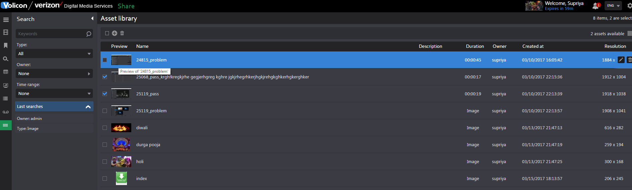
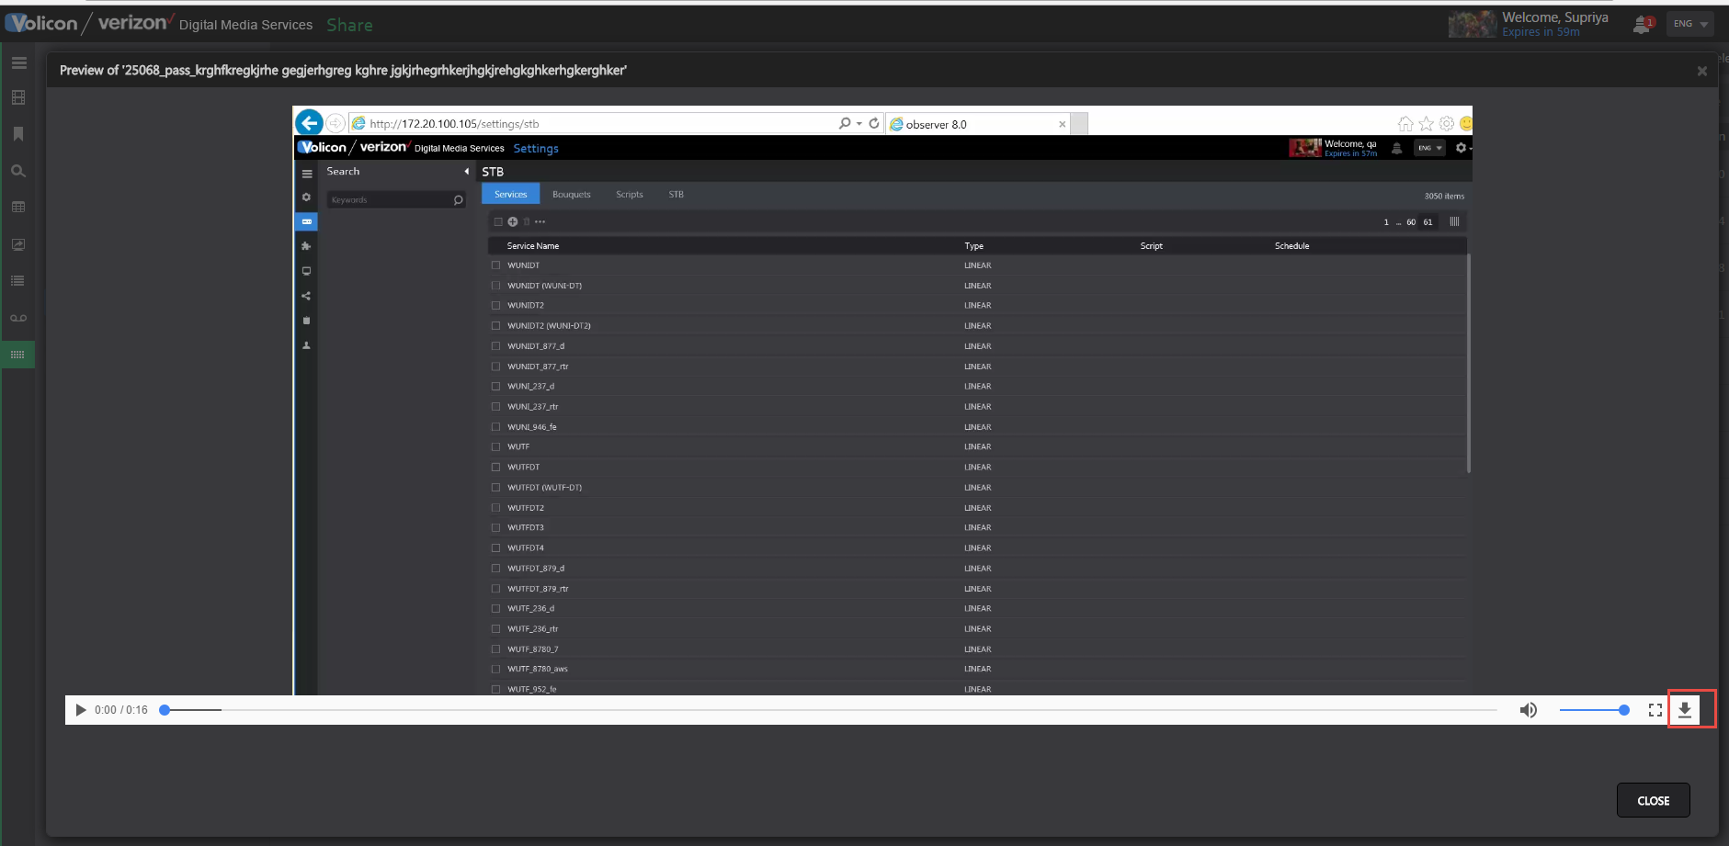

Editing Asset
- Click on the Edit button, which appears when user hovers mouse over Asset.
- Users will be able to change description and name of the Asset but not the file itself.
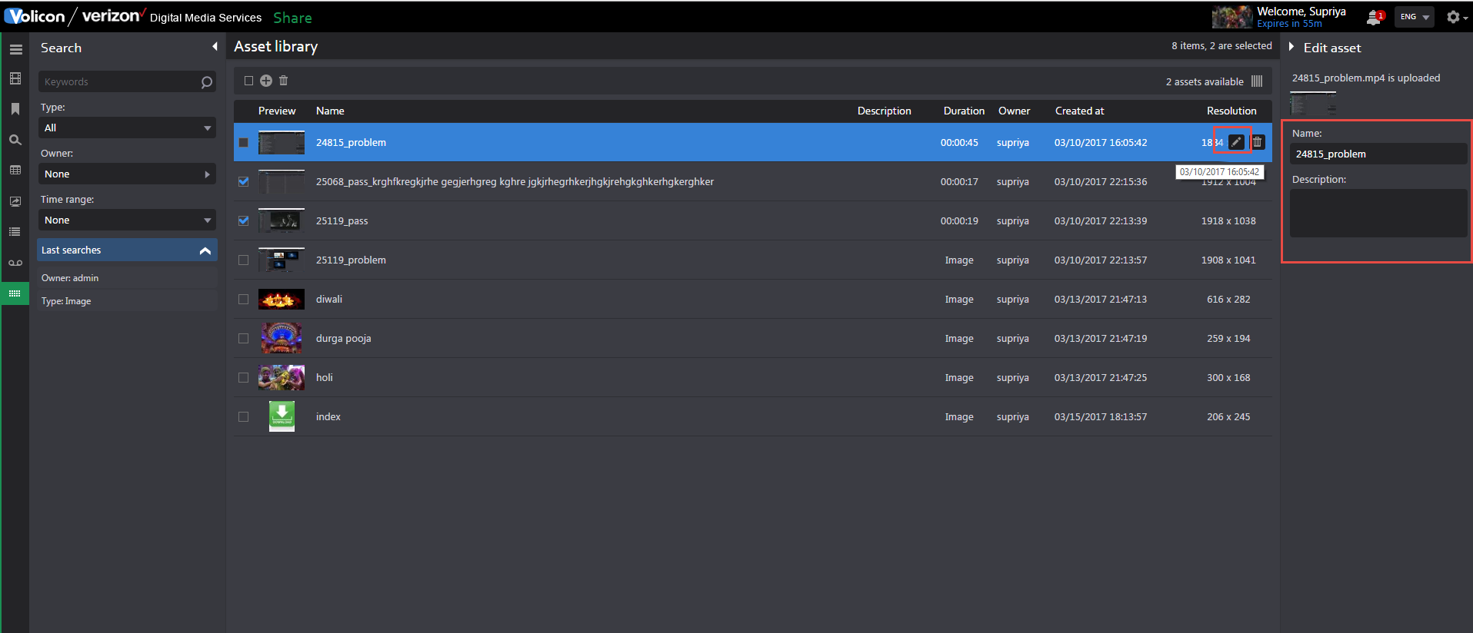

Filter Asset
- Users can filter Assets based on the following:
    - Keyword – Records having searched keyword in the Name column will be returned
    - Type – Search returns Video asset or Image Asset or both
    - Owner – Search returns assets created by Owner selected in filter
    - Time range – Search returns assets created within the selected time range in the filter

Share Light Editor Use
Adding Intro/Outro to clip
- To add an Intro/Outro, create a clip and click the “Share” button it.
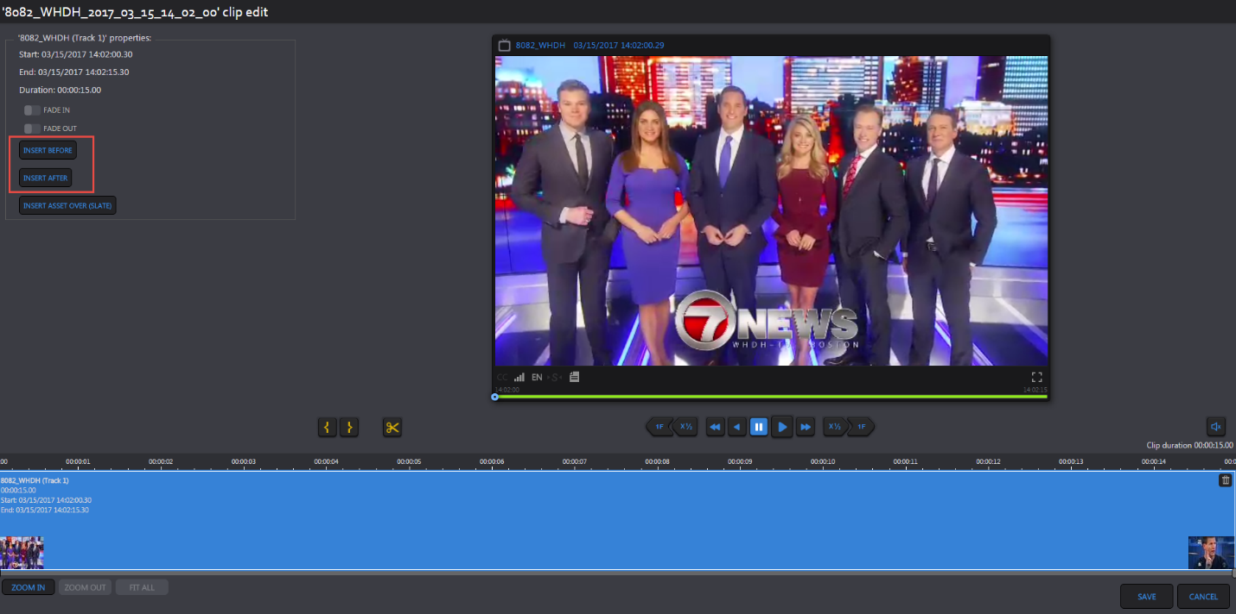
- From the Share page, click on the “LIGHT EDITOR” button as shown in the screenshot below.

- This brings you to the SLE page
- From there, to insert an Intro, click on “Insert Before” and to insert an Outro, click on “Insert After”
- A panel will pop up to select the Asset to be inserted as either an Intro or Outro. Notice that it displays Assets of “Video” type that are defined on Asset library page.
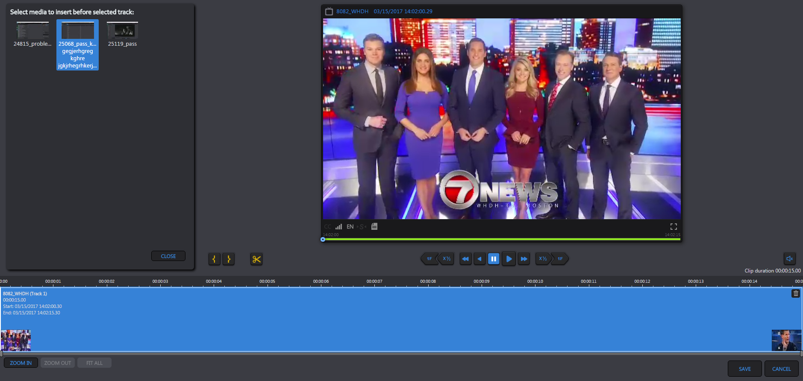
- After the user selects the desired Asset to use, it is displayed in Front and back of the clip in a different color to differentiate with the original track. Please see the screenshot below for reference.
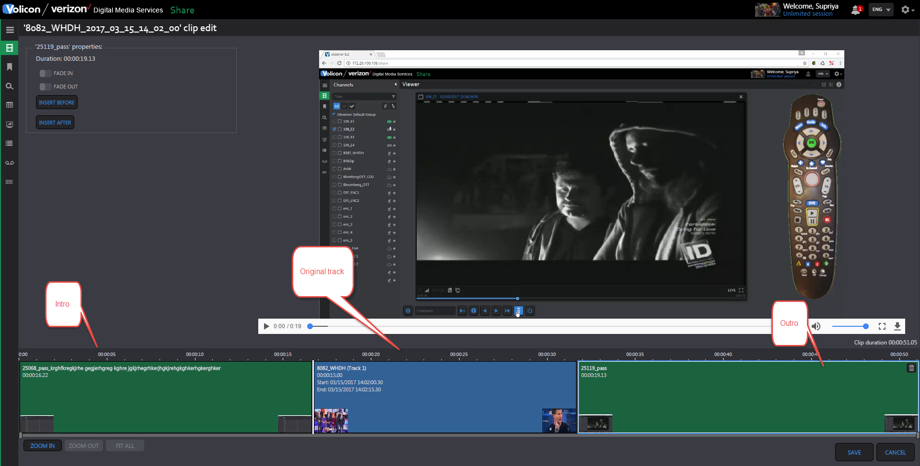

Splicing the track
- A track can be divided into multiple tracks by using the splicing button below the player.
- Click on the desired time in track pane at the bottom part of the page and then click on the “Splice” button to divide the track. Please see the screenshot below for reference.
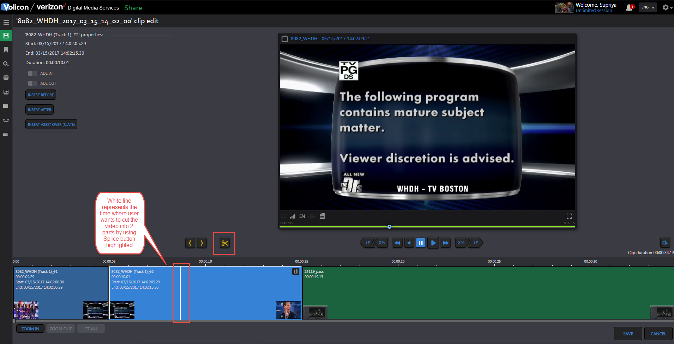
- After splicing, the user will see multiple tracks on the Share page, instead of just one.
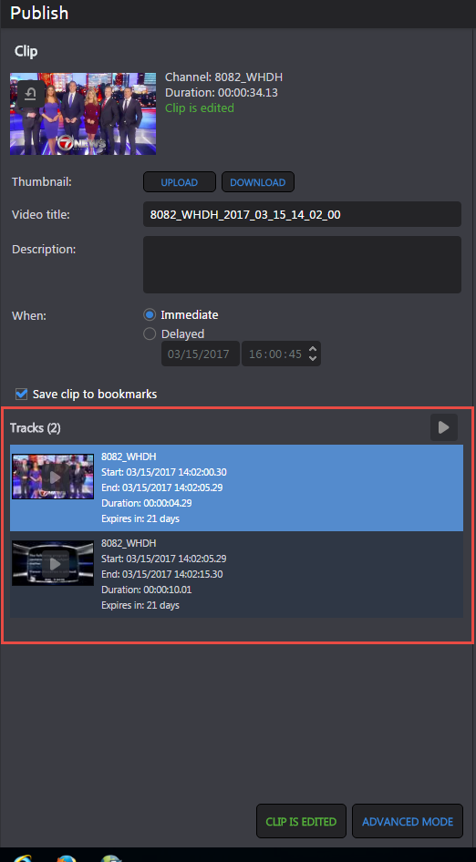

Adding Fade In/Fade Out
- Fade In/Fade Out is used in the case of sharing multiple tracks.
- To differentiate between multiple tracks (i.e. when the first track ended and the next track begins), black frames can be inserted between tracks. The default duration for which these frames are inserted is 2-3 seconds.
- To add fading, click on the track and track properties will start appearing on the panel.
- Click on “Fade In” to add black frames at the start of track and “Fade Out” to add black frames at the end of track. Please see the screenshot below for reference.
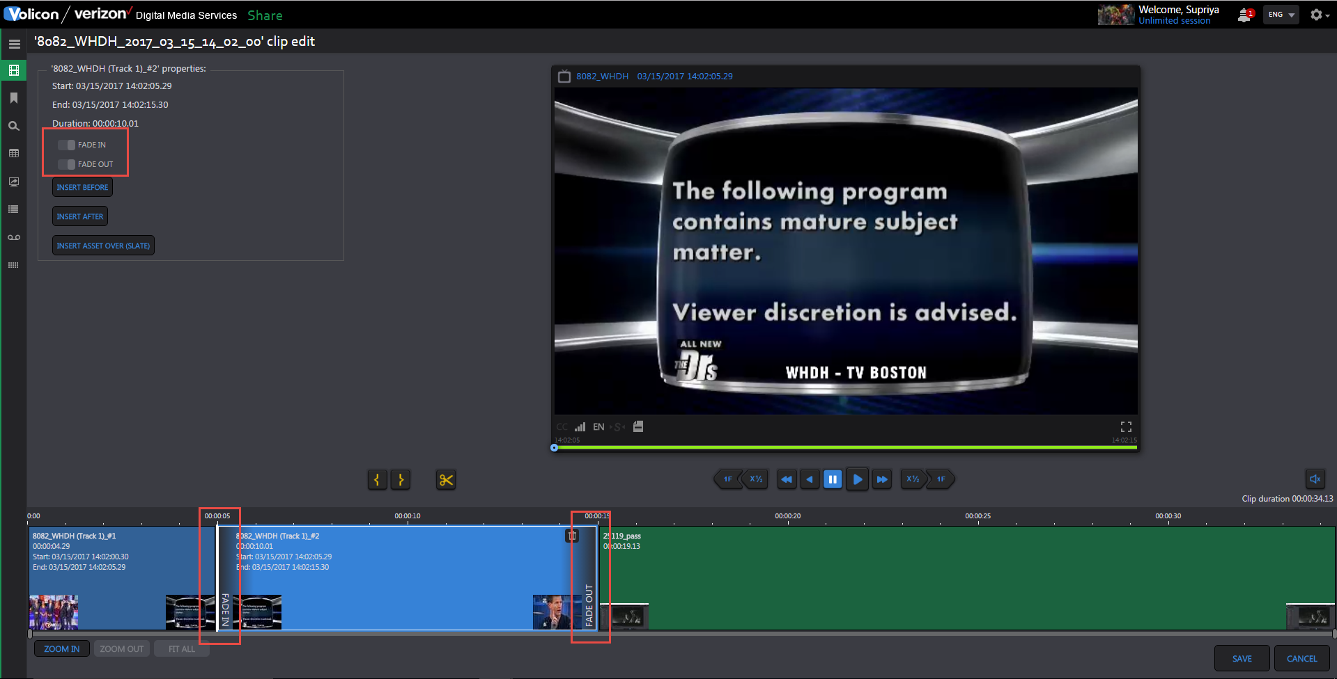
Adding Slate
- To insert a Slate Asset on the track, select the track and click on “Insert Asset over (Slate)”.
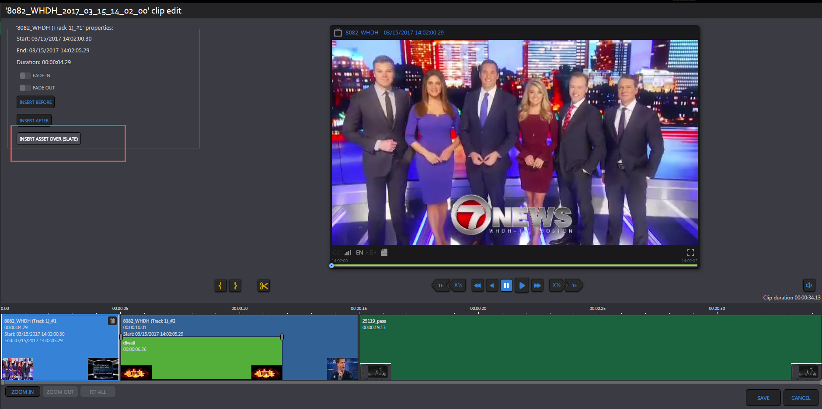
- A panel will appear with the list of “Image” Assets defined in Asset library page that can be used for Slate.
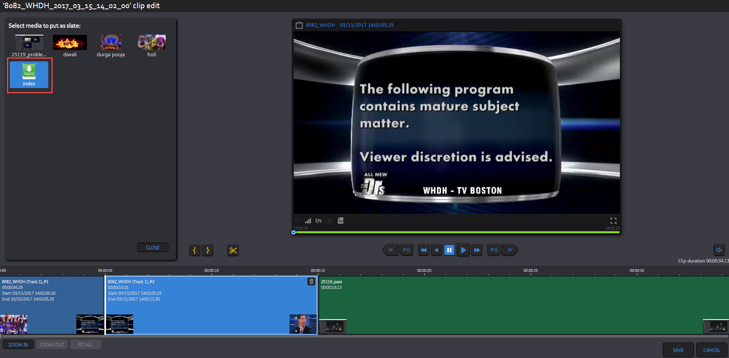
- Select any of these “Image” Assets to be added as Slate.
- Once selected, the user can change the start time, end time and duration of Slate manually.
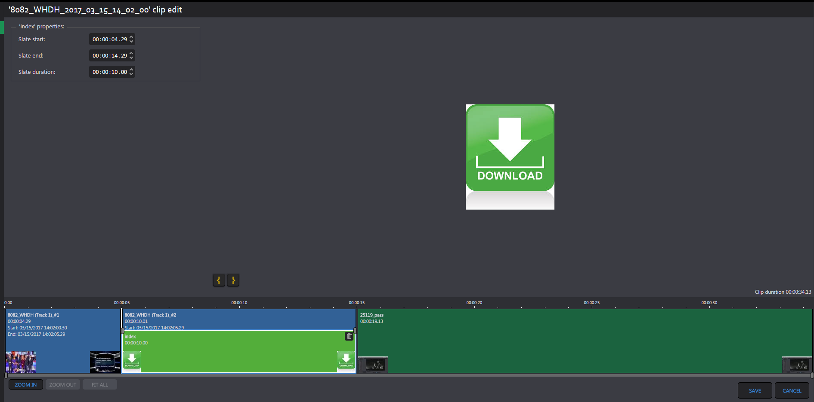

NOTES**:
- Fade-In/Fade-Out can be added to Intro/Outro track as well.
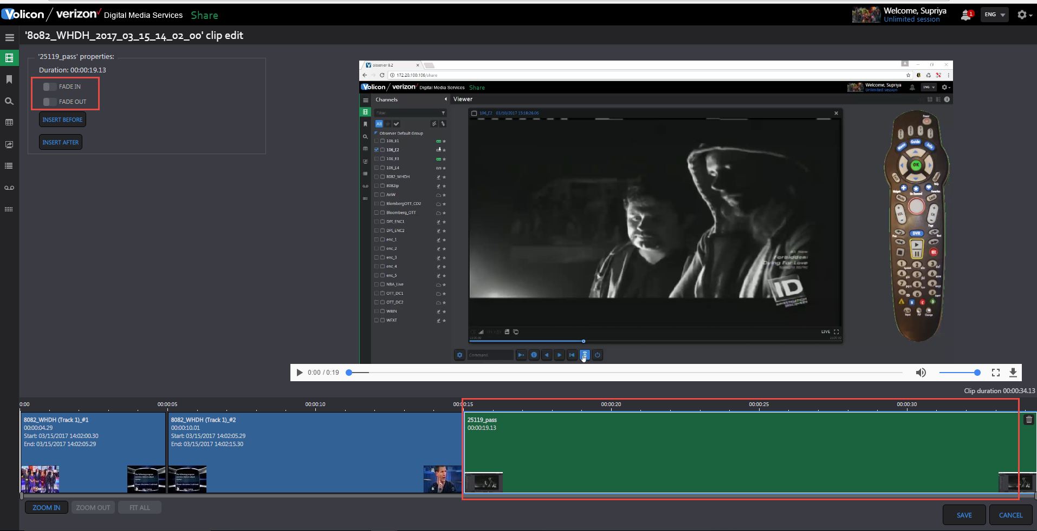

- Slates cannot overlap Intro/Outro but they can overlap multiple tracks – spliced or otherwise.
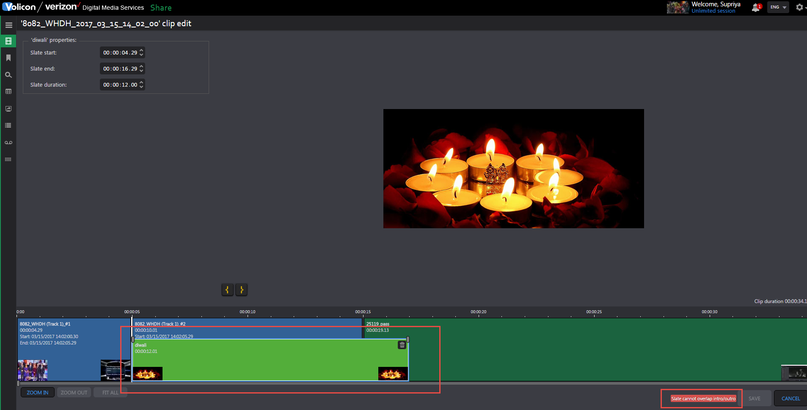

- Any Asset or track can be deleted by clicking on Delete button which appears over each asset.
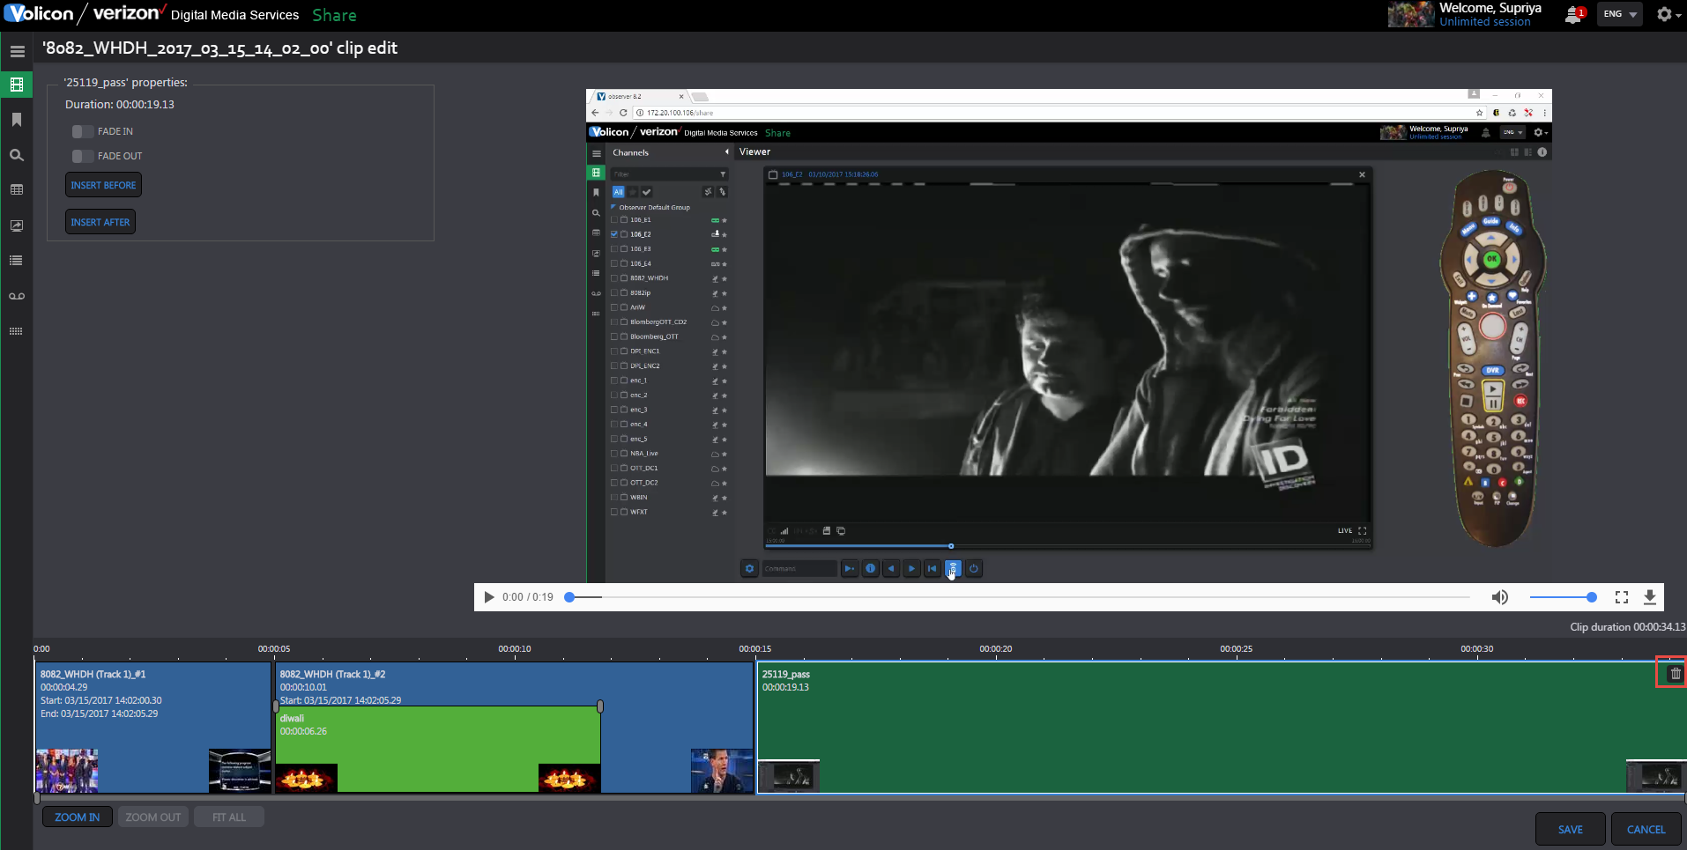

- If user edits a clip using Light Editor, the button is renamed on Share page to “CLIP IS EDITED”
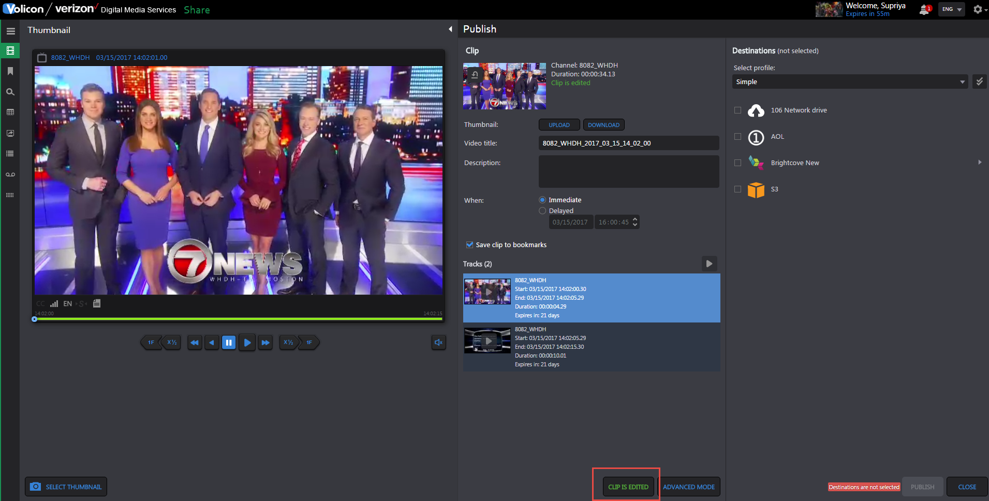

LocalShare
Overview:
LocalShare allows user to take advantage of the Light Editor features to add intros/outros and slates to files that are being exported locally rather than to a Share destination.

Creating LocalShare Destination

- No parameters required to create this destiantion - simply click on “Apply”.
- The name of the destination is automatically set as “Save as Local Link”.
- It’s possible to create only one.

Publishing

- When a user chooses to Share to LocalShare, the clip is processed by the CEM and then written to the default local path on the CEM.
- The file can then be retrieved from the CEM by either:
  - A persistent button that appears immediately on the Volicon GUI, just like a standard local export.
  - Via email, if the user's preference to send email links to CEM processed jobs is checked for the given user.
- If the export profile being used with this destination includes a caption file, then the system will zip the caption file and the output file together and provide a link to the zip file.

Multi Share
Overview:
Multi Share allows users to pick several destinations from several different profiles for specific Assets. The system will trigger several jobs, one job per publish profile.
- When sharing, select the desired destinations
- Notice that the tag icon appears next to the publish profiles and an indication to number of destinations and publish profiles will be presented next to “Destinations”:
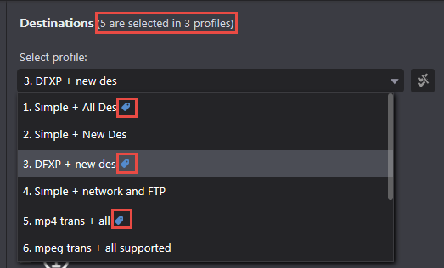
- In order to remove the tag from a publish profile, the destinations selected under this profile need to be deselected.
- The publishing progress will be presented as following:
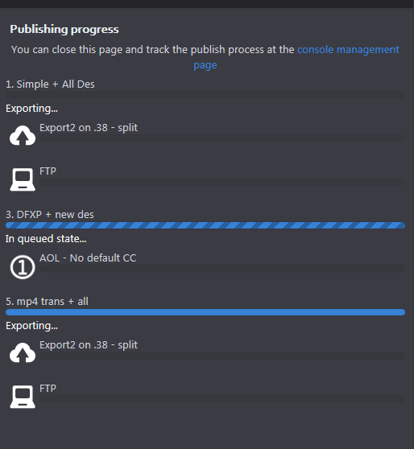
- In the management console - a job per publish profile is displayed:
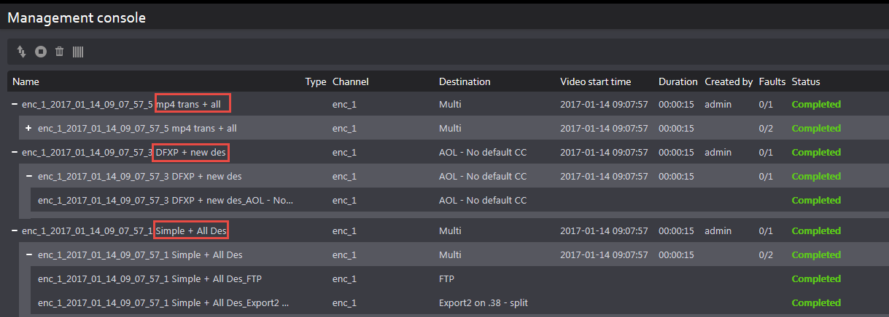

Bug Fixes
Description
Management Console: "Local Export" destination is shown as blank in filter
Viewer- Loudness meter- 4 columns should be in gray (Chrome)
Management Console: "Destination" filter is empty- All other filters have data populated
Management Console: Search and reset button disappear from page and no search is performed on the page
Cont\Sch export - number of items is not represented correctly, some jobs are not present
8.1.3 Upgrade - Artisan update fails when upgrading from 8.0QB4.3 to 8.1.3
Share: CC file is created empty when CC language is different from the export profile
Light Editor: Move between clips - multiple viewers run on screen (html5)
Share: audio is not checked, if the audio tracks of the encoder don't match the export profile
Sch Export - Unable to add\remove destinations after clicking on Twitter
Light editor: When 2 slates overlap, removing one changes the length and position of the other
Share is not working ×Ÿin case of TZ '+'
Media hub - QueryMediaFileInfo for specific playbacks return error
CEM - Twitter fails to publish
Configuration - Unable to change configuration Via FE
Cont\Sch Export - Saving not possible when editing a job that is already running
Share light editor - No message about "unable to delete last track"
Share light Editor: Unable to delete tracks/assets on Share page due to error in Console log
Cont\Sch Export - Disabling a job while occurrence is exporting, often creates 2 publish instances
8.1.3_Viewer: CC Container does not load CC for specific encoders
Cont\Sch export -Unable to change "Starts on" to a past date\time, for pending jobs
CC Export page- Player disappears when selecting a line
MV - Play buttons and calendar on quarantine aren't aligned
Installation failed - Artisan update
MV edge - Alert notification on player is cut
MV - User that didn't create the screen cannot see players
Share - Window opens blank (JS error)
Multiview - Player widgets have multiple issues
MV - unable to add MV room
Share light editor: Correct asset does not play until user goes to main clip
QVC US SF00026684 Artisan update failed 8.0QB4.3 to 8.1.1QB
Add a button to start encoder in dummy mode
StoryBoard Marking: Edit clip - next page - start&end time are invalid
StoryBoard Marking: Edit clip - previous page - clip length is 0
NBC SF00026575 CCindexing failed after DST change.
Case 26541 - Allyn - Twitter new share resolution limitation
Fault Clips page - clicking on a clip opens a blank edit clip page
Customer defined legal/IT warning on every login
CloudDirect encoders dropping keyframes when dealing with a recurring segment
CEM - Need to add support for new publisher: EMC's ECS
MV - Alerts not updated unless user refreshes screen
Share/Export/Closed Captions: "Unspecified Error" keeps appearing on FE
Marking multiple clips then exporting one individually -> lose cliplist unless you press "apply" first
Preferences - Time zone drop down shows empty
HTML5 Player shows "Unsupported Format" error for a CloudDirect encoder with CC
Add a transcoding command for ffmpeg center crop
Add ability to upload to FB as "un-published"
Multiview - Video aspect ration is wrong when using F11 mode and audio bars
Reset cache is not functioning - its should clear all players
Allyn SF25786, False positive PMT changes restart the encoder.
Add link to local file as destination for Share
Share light editor - Sometimes "regular" share fails with Twitter error
Channel 5 - SF25984 - drift between audio and video is too big, restarting

Known Bugs and Limitations

Light Editor open issues:
Description
Light Editor: Pressing an unmarked clip randomly brings use to the end/beginning
Light Editor / Slates: Inserted end time can be earlier than current start time
Light Editor: Slates can overlap (if their start point is the beginning of the same slate)
Asset Library: Validation message not informational in case of long file
Assets Library: Cannot preview video using Safari (stuck on loading)

Continuous and Schedule Export open issues:
Description
Cont/Sch Export: "No items to view" although page is not empty
Cont/Sch Export: Typing is not smooth in "Video Title" field
Cont/Sch Export: User sees jobs for channels not present in channels set
Cont/Sch Export: Internal Server Error when editing a job
Edit Cont Jobs: "Ends" value changes from "Never" to "After"
Cont/Sch Export: Default values are displayed for some fields when editing
Cont Export: Changing start\End overlap has no affect when job is running
Cont/Sch Export: Implement auto-refresh functionality and clone Management Console behavior
Cont/Sch Export: Any user able to edit jobs created by super-user
Automation: Add cont/sch export to "all pages" test
Management Console: Created by "All" and "None" filters show super-users
Sch Export: Status remains on "pending" even after job was published

Share & Export
Description
Share/Export: Only partial timestamp displayed for specific scenario
Share: Profiles should not minimize if there is error so that user can correct it
Management Console: need to change error message when EMC publish fails due to wrong credentials
Share: Closed captions not seen on Uplynk local when encoder has 2 languages
Share: List of destinations should be sorted alphabetically when sorting by destination
Share: Internal Server error appears if user publishes the same clip twice
Share: Shared clip to Twitter via BrightcoveNew destination does not play in the link
Share: Wrong video resolution data on advanced option
Share Light Editor: Fade-In does not work in case Intro is a short clip
Share: S3 label text isn't alligned
Share: Default CC format show empty value when adding new destination
Destination - Twitter: Brightcove New destinations do not appear in "Transport Profile" dropdown
Destination – Youtube: The advanced tag isn't cleared after removing tag
Publish Profiles: New profile window minimizes when error about Twitter appears
Share: Thumbnail with high resolution is blank on the MPX destination
Share: Time zone is not displayed fully in a specific case
Share - DPI Monitoring: Select thumbnail is not smooth like on the regular Share page
Share Light Editor: Cannot see preview of images/video on Share window
Destination – Facebook: Save button should be grayed out until logged in
Destination – Facebook: Unable to add destination if account already logged in using same browser
Share Light Editor: Light Editor button is not visible even when selected
Share light editor: Time changes on player if user click on Delete button
Share/Export: Banner preview window has "Close" button cut in case of particular image
Share light editor: Control jumps to start of clip when user clicks on the Tracks section
User Activity: Share/export time shows UTC time
ACE: Current track loses focus when user clicks on Start/End track
Management Console: Expand All button does not work in the first attempt
ACE: Player pauses instead of forwarding the next track
ACE - HTML5 Player: Player does not start to play the first time user clicks on Thumb "play" button

HTML5 open issues:

Description
HTML5 streamer should support https protocol
Teletext support in HTML5 player
Permissions: Need to grey out "Local export using IE" when setup->Player type using IE is HTML5
HTML5: Rewind & 'play rewind' plays in lags
HTML5: Player frame is blank at a specific time
Viewer: Adding and removing players messes up appearance
HTML5: Player jumps over the gap with no notification but ActiveX player notifies user
HTML5: OTT encoders become stuck
HTML5: 4 extra loudness bars are present when switching from surround to Downmix
HTML5 – Safari: Loudness bars not shown correctly on specific channel
HTML5: XDS metadata is missing the encoder_name@probe_ip line
HTML5 – Edge: Player time can move forward when encoder is down

